**UTEP Team**

**MPO System Software Requirements Specification Version <2.6>**

**2/18/2016**

**Document Control**

**Approval**

The Guidance Team and the customer shall approve this document.

**Document Change Control**

|  |  |
| --- | --- |
| Initial Release: | 0.1 |
| Current Release: | 2.5 |
| Indicator of Last Page in Document: | ♣ |
| Date of Last Review: | 2/17/2016 |
| Date of Next Review: | 2/26/2016 |
| Target Date for Next Update: | 2/26/2016 |

**Distribution List**

This following list of people will receive a copy of this document every time a new version of this document becomes available:

Project Team: Dr. Ann Gates

Dr. Natalia Villanueva Rosales

Dr. Salamah Salamah

Elsa Tai Raquel Lopez Erick Garcia

Customer: Metropolitan Planning Organization led by Mr. Roger Williams

**Change Summary**

The following table details changes made between versions of this document

|  |  |  |  |
| --- | --- | --- | --- |
| Version | Date | Modifier | Description |
| 0.1 | 12/01/2015 | Elsa Tai | Created a draft document. |
| 0.2 | 12/14/2015 | Elsa Tai | Modified the use case section. |
| 0.3 | 01/04/2016 | Elsa Tai | Modified the use case section. |
| 0.4 | 01/05/2016 | Elsa Tai | Modified the state transition diagram. |
| 0.5 | 01/10/2016 | Elsa Tai | Modified the class diagram. |
| 0.6 | 01/15/2016 | Elsa Tai | Modified the user interface section. |
| 0.7 | 1/18/2016 | Elsa Tai | Modified the user interface and real world  object sections. |
| 0.8 | 1/20/2016 | Elsa Tai | Modified the real world object section. |
| 0.9 | 1/22/2016 | Elsa Tai | Modified the user interface and real world  object section. |
| 1 | 1/23/2016 | Elsa Tai | Modified the real world object section. |
| 1.1 | 1/23/2016 | Dr. Gates | Reviewed and corrected contents in sections 1,  2, and 3. |
| 1.2 | 1/26/2016 | Elsa Tai | Corrected contents in section 3.1. |
| 1.3 | 1/27/2016 | Dr. Gates, Dr.  Villanueva Rosales, Raquel Lopez, and Elsa Tai | Reviewed contents in sections 1, 2, and 3. |

|  |  |  |  |
| --- | --- | --- | --- |
| **Software Requirements Specification** |  | **Date**  2/18/2016 5:20 PM | **Page**  ii |

|  |  |  |  |
| --- | --- | --- | --- |
| 1.4 | 2/1/2016 | Elsa Tai | Corrected contents in section 3.1.  Modified use case diagrams to include a MPO Lead user. |
| 1.5 | 2/2/2016 | Elsa Tai | Corrected contents in section 3.1. |
| 1.6 | 2/3/2016 | Elsa Tai | Corrected contents in section 3.1. |
| 1.7 | 2/4/2016 | Elsa Tai | Corrected contents in section 3.1. |
| 1.8 | 2/7/2016 | Elsa Tai | Corrected contents in section 3.1. |
| 1.9 | 2/7/2016 | Elsa Tai | Modified the real world object section. |
| 2.0 | 2/10/2016 | Elsa Tai | Modified the user interface section. |
| 2.1 | 2/12/2016 | Elsa Tai | Modified the real world object section. |
| 2.2 | 2/13/2016 | Dr. Gates | Reviewed and changed contents in the real  world object section. |
| 2.3 | 2/15/2016 | Elsa Tai | Corrected contents based on Dr. Gates’  comments. |
| 2.4 | 2/17/2016 | Dr. Gates and Elsa  Tai | Worked on the real world object and stimulus  sections. |
| 2.5 | 2/18/2016 | Erick Garcia | Added financial requirements and financial  interfaces. |
| 2.6 | 2/18/2016 | Elsa Tai | Worked on the real world object and stimulus  sections.  Added class diagram and state transition diagram. |

|  |  |  |  |
| --- | --- | --- | --- |
| **Software Requirements Specification** |  | **Date**  2/18/2016 5:20 PM | **Page**  iii |

**TABLE OF CONTENTS**

**DOCUMENT CONTROL ...........................................................................................................................II**

APPROVAL....................................................................................................................................................II DOCUMENT CHANGE CONTROL ...................................................................................................................II DISTRIBUTION LIST ......................................................................................................................................II CHANGE SUMMARY .....................................................................................................................................II

**1. INTRODUCTION .................................................................................................................................6**

1.1. PURPOSE AND INTENDED AUDIENCE ................................................................................................6

1.2. SCOPE OF PRODUCT..........................................................................................................................6

1.3. DEFINITIONS, ACRONYMS, AND ABBREVIATIONS.............................................................................6

*1.3.1. Definitions ...............................................................................................................................6*

*1.3.2. Acronyms .................................................................................................................................7*

*1.3.3. Abbreviations...........................................................................................................................8*

1.4. OVERVIEW .......................................................................................................................................8

1.5. REFERENCES ....................................................................................................................................8

**2. GENERAL DESCRIPTION.................................................................................................................9**

2.1. PRODUCT PERSPECTIVE ....................................................................................................................9

2.2. PRODUCT FEATURES ........................................................................................................................9

*2.2.1. Actors Descriptions .................................................................................................................9*

*2.2.2. Use Case Descriptions.............................................................................................................9*

2.3. USER CHARACTERISTICS ................................................................................................................13

2.4. GENERAL CONSTRAINTS ................................................................................................................13

2.5. ASSUMPTIONS AND DEPENDENCIES................................................................................................13

**3. SPECIFIC REQUIREMENTS...........................................................................................................14**

3.1. EXTERNAL INTERFACE REQUIREMENTS .........................................................................................14

*3.1.1. User Interfaces ......................................................................................................................14*

*3.1.2. Hardware Interfaces ..............................................................................................................63*

*3.1.3. Software Interfaces ................................................................................................................63*

*3.1.4. Communications Interfaces ...................................................................................................63*

3.2. BEHAVIORAL REQUIREMENTS ........................................................................................................64

*3.2.1. Same Class of User ................................................................................................................64*

*3.2.2. Related Real-World Objects ..................................................................................................65*

*3.2.3. Stimulus .................................................................................................................................73*

3.3. NON-BEHAVIORAL REQUIREMENTS................................................................................................75

**APPENDIX A: FIELD VALUES ..............................................................................................................76**

A.1 FEDERAL FUNCTIONAL CLASSIFICATION .............................................................................................76

A.2 PROJECT TYPE .....................................................................................................................................77

A.3 AREA ...................................................................................................................................................77

A.4 PHASE IDENTITY ..................................................................................................................................78

A.5 PROJECT EXTENSION ...........................................................................................................................78

A.6 PROJECT PHASES .................................................................................................................................78

A.6 CITY ....................................................................................................................................................78

A.7 PROJECT SELECTION INFORMATION.....................................................................................................79

A.8 PROJECT READINESS ELEMENTS..........................................................................................................82

A.4 FUNDING SOURCE ................................................................................................................................82

**APPENDIX B: CLASS DIAGRAM ...........................................................................................................84**

**APPENDIX C: STATE TRANSITION DIAGRAM ................................................................................85**

C.1 OVERVIEW ...........................................................................................................................................85

C.2 PREPARING SUBMISSION SUPERSTATE .................................................................................................86

|  |  |  |  |
| --- | --- | --- | --- |
| **Software Requirements Specification** |  | **Date**  2/18/2016 5:20 PM | **Page**  iv |

C.3 REVIEWING SUBMISSION SUPERSTATE ................................................................................................87

|  |  |  |  |
| --- | --- | --- | --- |
| **Software Requirements Specification** |  | **Date**  2/18/2016 5:20 PM | **Page**  v |

**1. Introduction**

**1.1. Purpose and Intended Audience**

The purpose of the Software Requirements Specification (SRS) is to give the customer a clear and precise description of the functionality of the proposed El Paso Metropolitan Planning Organization (MPO) system. The SRS divides the system requirements into two parts, behavioral and non-behavioral requirements. The behavioral requirements describe the interaction between the system and its environment. Non-behavioral requirements relate to the definition of the attributes of the product as it performs its functions. This includes the level of security, efficiency, reliability, maintainability, and portability of the product. The intended audience of the SRS is the El Paso Metropolitan Planning Organization and the UTEP team. This document serves as an agreement between both parties regarding the product to be developed.

**1.2. Scope of Product**

The El Paso Metropolitan Planning Organization (MPO) is the regional planning and programming agency responsible for working with residents, neighborhood groups, local, state, and federal agencies, along with transportation providers in El Paso County, Texas, southern Dona Ana and Otero Counties in New Mexico [1]. MPO uses a number of artifacts for planning, programming, applying fiscal constraints, and tracking projects of regional significance. Currently, the artifacts are managed through various software systems, such as the Transportation Improvement Program (TIP), which is managed through Microsoft Access, geographical information about projects through a geographical information system (GIS), and the Metropolitan Transportation Plan (MTP) through Microsoft Excel. Data consistency and correctness are an issue.

The University of Texas at El Paso (UTEP) and the El Paso MPO are collaborating to develop a Web-based system (MPO system) that will manage project information regarding Texas and New Mexico highways and transit. The purpose of the MPO system is to streamline the process of capturing, maintaining, and archiving information for each required artifact in an efficient and timely manner. The MPO system will manage project information and provide the following services:

▪ Manage requests regarding information about proposed projects and programming that include the status of the project (proposed, under review, under construction, and completed), project ID, funding source, and impacted areas. The information can be presented in text form or as a map overlay. The user should be able to filter projects for viewing. If more detailed information is required, the user can retrieve the details through the system.

▪ Manage project information regarding Texas and New Mexico highways and transit.

▪ Manage creation of proposed projects, update of projects, deletion of projects, and archival of projects,

▪ Manage creation of project-related reports.

**1.3. Definitions, Acronyms, and Abbreviations**

**1.3.1. Definitions**

The definitions in this section are given in the context of the product being developed. This intention is to assist the user in their understanding of the document.

Table 1: Definition of terms used in the report

|  |  |
| --- | --- |
| **TERM** | **DEFINITION** |
| Active project | A project that has been approved for funding and less than 5 years from the date of completion. |
| Actor | A representation in the use case diagram denoting external entities that interact with a system being modeled, e.g., the MPO system. |

|  |  |  |  |
| --- | --- | --- | --- |
| Software Requirements Specification |  | Date  **2/18/2016 5:20 PM** | Page  **6** |

|  |  |
| --- | --- |
| Archived project | A project that has been completed for at least 5 years, or has been recommended for archive by the MPO Lead user. |
| Extend Relationship | Denotes insertion of optional behavior of another use case into the primary use case. |
| Federal/Functional  Classification | A process by which streets and highways are grouped into classes, according to the characteristics of service they intend to provide. |
| Funded project | A project that has been approved for funding by TPB, state, and/or federal agency. |
| Generalization  Relationship | Denotes a relationship between a general use case and a specific use case. |
| Include Relationship | Denotes the inclusion of behavior of another use case into the primary use case. |
| Metadata | Data about a project that tracks who has made a change, when, and why. |
| Mouseover menu | A window that appears when the user hovers the pointer over its trigger area. |
| MPO Lead user | An individual who oversees the MPO activities and is authorized to make decisions regarding access and project administration. |
| Off-system roadway | Roadway that are not designated on the State Highway System and are not maintained by TxDOT [2] |
| On-system roadway | Roadway that are designated on the State Highway System and maintained by  TxDOT [2]. |
| Pop-up | A new browser window that appears in the foreground of an interface. |
| Project Identifier | A temporary ID that is given to project that being prepared for submission. |
| Project Lead | An entity that is responsible for filling out a project request form when submitting projects for funding considerations. Also referred to as municipality. |
| Proposed project | A project request form submitted by a Project Lead for review by the MPO staff. |
| Submitted project | A project under review by the TPB, state, and/or federal agency. |
| Termini | Start and end points to denote the portions of a highway that will undergo construction. |
| Use Case | A modeling technique that presents the basic functionality of a system and the actors that interact with each function. |
| Workflow | A sequence of steps needed to complete the submission of a proposed project or to complete the tasks associated with the programming of a funded project. |
| Workflow status | The current step of a workflow. |

**1.3.2. Acronyms**

This section lists the acronyms used in this document and their associated definitions.

Table 2: Acronyms

|  |  |
| --- | --- |
| **TERM** | **DEFINITION** |
| CMP | Congestion Management Process |
| CN | Control Number |
| CSJ | Control Section Job |
| DOT | Department of Transportation |
| FTA | Federal Transit Administration |
| FY | Fiscal Year |
| GIS | Geographical Information System |

|  |  |  |  |
| --- | --- | --- | --- |
| Software Requirements Specification |  | Date  **2/18/2016 5:20 PM** | Page  **7** |

|  |  |
| --- | --- |
| ID | Identification |
| MPO | Metropolitan Planning Organization |
| MTP | Metropolitan Transportation Plan |
| PDF | Portable Document Format |
| SQL | Structured Query Language |
| SRS | Software Requirements Specification |
| TDC | Transportation Development Credit |
| TIP | Transportation Improvement Program |
| TPB | Transportation Policy Board |
| YOE | Year of Expenditure |

**1.3.3. Abbreviations**

This section provides a list of used abbreviations and their associated definitions.

Table 3: Abbreviations

|  |  |
| --- | --- |
| **TERM** | **DEFINITION** |
| e.g. | For example |
| i.e. | That is |
| TBD | To be determined |

**1.4. Overview**

The SRS is divided into three major sections: Introduction (Section 1), General Description (Section 2), and

Specific Requirements (Section 3).

Section 1 includes five subsections. Section 1.1 provides the purpose and intended audience of the document. Section 1.2 describes the scope of the product. Section 1.3 provides the definitions, acronyms and abbreviations. Section 1.4 provides the organization of the document. Section 1.5 lists the references used in this document.

Section 2 includes five subsections. Section 2.1 contains a description of the product, its overall structure, and its functionality. Section 2.2 summarizes the main features of the MPO system. Section 2.3 identifies each type of users of the system. This is accomplished through a summary of actors and use-cases. Section 2.4 states existing general constraints. Section 2.5 gives the assumptions and dependencies of the MPO system.

Section 3 includes four major subsections. Section 3.1 contains requirements that are related to the external interface. Section 3.2 contains the functional requirements that are organized in the following categories: same class of user, related real-world objects, stimulus, related features, and limits and default settings. Section 3.3 contains non-behavioral requirements consisting security and maintainability requirements.

**1.5. References**

[1] El Paso Metropolitan Planning Organization (2016, Feb 18). El Paso MPO. Available:

<http://www.elpasompo.org>.

[2] TxDOT (2016, Feb 18). Highway Designations Glossary. Available: <http://www.txdot.gov/inside-> txdot/division/transportation-planning/highway-designation/glossary.html.

|  |  |  |  |
| --- | --- | --- | --- |
| Software Requirements Specification |  | Date  **2/18/2016 5:20 PM** | Page  **8** |

**2. General Description**

**2.1. Product Perspective**

El Paso MPO uses a number of artifacts for planning, programming, applying fiscal constraints, and tracking projects of regional significance. The artifacts are currently being kept in various data sources, such as TIP in Microsoft Access, geographical information about projects in a GIS, and MTP in a Microsoft Excel file. Data consistency and correctness become an issue. The MPO system streamlines the process of capturing, maintaining, and archiving information for each required artifact in an efficient and timely manner.

**2.2. Product Features**

Figure 1 presents a level 1 use case diagram that provides an overview of the main functionalities provided by the MPO system and the interactions between actors and the system. Figure 3 presents the notations used in a use case diagram. The actors, represented by stick figures, are external entities that interact with the MPO system. The use cases, represented by ovals, elucidate the actors’ interactions with the MPO system. Figure 2 presents a level 2 use case diagram that provides extensions of the functionalities, in particular the *include*, *extend*, and *generalization* interactions between the actors and the system. The *include* relationship denotes the inclusion of behavior of another use case into the primary use case. The *extend* relationship denotes insertion of optional behavior of another use case into the primary use case. The *generalization* relationship denotes a relationship between a general use case and a specific use case. These components are described next.

**2.2.1. Actors Descriptions**

The MPO system classifies actors into the following groups:

▪ Project Lead: This actor represents the entities, e.g., municipalities, that are applying for funding for projects.

▪ MPO Staff: This actor represents the employees of the El Paso MPO.

▪ Regular User: This actor represents anyone who has an interest in transportation projects.

▪ GIS: This actor represents an application that generates maps of project locations.

▪ Administrator: This actor represents an employee of the El Paso MPO who is responsible for maintaining the MPO system, in particular managing accounts and permissions for MPO system users.

▪ Land-use Component: This actor represents an application that evaluates land use impacts of

transportation improvement projects and performs forecasts on future location of employment and households.

▪ MPO Lead user: This actor represents an employee of the El Paso MPO who oversees the MPO activities

and is authorized to make decisions regarding access and project administration.

**2.2.2. Use Case Descriptions**

The MPO system supports the following primary use cases:

▪ Create submission: Complete and submit an application to MPO to request funding for a transportation project.

▪ Edit submission: Edit the funding request to the MPO.

▪ Delete submission: Retract the submission of a project to MPO.

▪ Create user account: Create an account for accessing functionality related to managing submissions.

▪ Edit user account: Edit attributes of the user account.

▪ Delete user account: Remove a user’s account from the system.

▪ Review submission: Capture the results of review of an application regarding completeness of the submissions, correctness of submitted information, and adherence of submitted information to local, state, and federal regulations. The review can result in returning the application to the submitter with feedback, or approval to submit.

▪ Evaluate transportation planning: Capture the evaluation of the potential land use impact of projects with respect to the economy and future location of employment and households.

|  |  |  |  |
| --- | --- | --- | --- |
| Software Requirements Specification |  | Date  **2/18/2016 5:20 PM** | Page  **9** |

▪ Manage programming: Manage the lifecycle of funded projects by documenting and maintaining project information including project progress, project financials, and decisions made by MPO, state, and federal agencies.

▪ Manage funding: Document, track, and manage local, state, and federal funds.

▪ Generate report: Create various types of federally mandated, state required, and custom reports in compliance with local, federal, and state laws and regulations. Reports can be generated from scratch or from an existing template and stored in various formats, such as, excel and pdf.

▪ Approve submitted project: Document individual recommendations and comments on projects and capture the board’s voting decisions on submitted projects.

▪ View: View reports, maps, and project information of interest.

▪ Archive: Archive projects.

The MPO system supports the following include, extend, and generalized use cases:

▪ Review model: Provide the ability to perform assessment on models for highway related projects.

▪ Login: Login in to the system to have access to functionality related to submissions.

▪ View report: As described by the use case name.

▪ View map: As described by the use case name.

▪ View general project information: As described by the use case name.

▪ View project details: As described by the use case name.

▪ Log changes: Document information regarding who and when information regarding projects is created, modified, and deleted.

▪ Provide feedback: As described by the use case name.

|  |  |  |  |
| --- | --- | --- | --- |
| Software Requirements Specification |  | Date  **2/18/2016 5:20 PM** | Page  **10** |

**MPO System**

Create Submission

Create User Account

MPO Lead User

Project Lead

Edit Submission

Edit User Account

Delete Submission

Delete User Account

Administrator

Review Submission

Evaluate

Transportation Planning

Landuse Component

MPO Staff

Manage Funding

Manage Programming

Generate Report

Approve Submitted

Project

Regular User

View

Archive

GIS

Figure 1: Level 1 Use Case Diagram

|  |  |  |  |
| --- | --- | --- | --- |
| Software Requirements Specification |  | Date  **2/18/2016 5:20 PM** | Page  **11** |

**MPO System**

Create Submission

Create User Account

Edit Submission

Edit User Account

MPO Lead User

Delete Submission

Delete User Account

Project Lead

<<Include>>

<<Include>>

Administrator

Review Submission

<<Extend>>

Evaluate

Transportation Planning

<<Include>>

Log Information

Review Model

Manage Programming

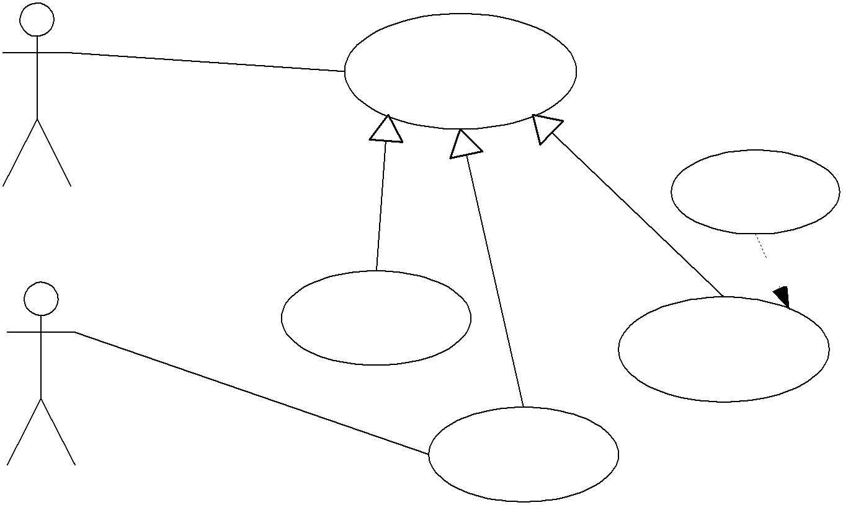

<<Include>>

MPO Staff

Manage Funding

Generate Report

Login

Landuse Component

Archive

Approved Submitted

Project

<<Include>>

<<Extend>>

View

Regular User

Provide Feedback

View Project

Details

View Report

<<Extend>>

View General

Project Information

GIS

View Map

Figure 2: Level 2 Use Case Diagram

|  |  |  |  |
| --- | --- | --- | --- |
| Software Requirements Specification |  | Date  **2/18/2016 5:20 PM** | Page  **12** |

Use Case Diagram Notation

Primary

<<Include>>

Use Case

Association

Relationship



Include

Relationship

<<Extend>>

Actor

Extend Relationship Generalization Relationship

**2.3. User Characteristics**

Figure 3: Use Case Notation

There are six classes of users that will interact with the MPO system. A description of the users follows:

▪ The Regular User class represents the general public who has an interest in transportation projects. The typical user of this class has a variety of computer usage skills.

▪ The Project Lead User class represents users who has an interest in participating in transportation projects. The typical user of this class has a variety of computer usage skills.

▪ The MPO Staff User class represents users who are employees of the El Paso MPO. The typical user of this class is an experienced computer user and has expertise in the MPO domain.

▪ The Administrator User class represents a technical person who is responsible for the configuration and maintenance of computer system. The typical user of this class has technical expertise (i.e., has computer

usage skills beyond the power user level).

▪ The MPO Lead user class represents a person who oversees the activities at the El Paso MPO. The person of this class is an experienced computer user and has expertise in the MPO domain.

**2.4. General Constraints**

The general constraints on the development of the system are as follows:

▪ The system will be completed by the end of August 2016.

▪ Google Maps Javascript API will be used to generate maps of project locations.

▪ Google Maps Geocoding API web service will be used to generate maps of project locations.

▪ The database management system will be implemented in Microsoft Structured Query Language (SQL) Server.

▪ The MPO system will be designed to be compatible with the existing codes used in the Excel and Access data bases to denote the values associated with a field.

▪ Automation in the creation of the MPO ID is outside the scope of this project. It will be considered as future work.

▪ Archived projects will be moved out of the MPO system to an external database.

**2.5. Assumptions and Dependencies**

▪ The MPO will provide the “Welcome” message for the web page.

▪ The MPO will provide the official logo for the web page.

▪ The MPO will be responsible in maintaining the server and the security of the server.

▪ The MPO will provide the documentation of the formulas for the financials.

▪ The MPO will provide access to the Microsoft SQL Server or other database management system to the

UTEP teams no later than March 1st, 2016.

▪ The MPO will setup firewall to protect the data stored in the MPO system from external attacks.

▪ The UTEP team will use the SRS to implement the system.

▪ Evaluation of the existing codes used in the Excel and Access data bases is needed.

▪ Metadata will capture data about projects that track who made a change, when, and why.

|  |  |  |  |
| --- | --- | --- | --- |
| Software Requirements Specification |  | Date  **2/18/2016 5:20 PM** | Page  **13** |

**3. Specific Requirements**

**3.1. External Interface Requirements**

This section contains the specification of requirements for interfaces among different components and their external capabilities, including all its users, both human and other systems.

**3.1.1. User Interfaces**

This section describes the characteristics of each interface between the MPO system and its users. The main interfaces listed below will be described in the following sections:

▪ Home page

▪ Projects page

▪ Reports page

▪ Management page

▪ Financials page

▪ Administration page

▪ Register page

▪ Sign In page

▪ Contact Us page

**3.1.1.1. General**

[SRS 1] For the values of each drop down box, please refer to the requirements in section 3.2.2 and appendix A.

**3.1.1.2. Heading**

[SRS 2] As shown in Figure 4, the pre-login heading shall include the following:

a. Logo that represents the El Paso Metropolitan Planning Organization. b. Label that displays “El Paso Metropolitan Planning Organization”.

c. Text input box for searching labeled as “Search for items”.

d. Button labeled as “Search”.

e. Button labeled as “Register”.

f. Button labeled as “Sign in”.

Figure 4: Pre-login Heading



[SRS 3] As shown in Figure 5, the post-login heading shall include the following:

a. Label that displays “Welcome Back <<User Name>>”.

b. Logo that represents the El Paso Metropolitan Planning Organization. c. Label that displays “El Paso Metropolitan Planning Organization”.

d. Text input box for searching labeled as “Search for items”.

e. Button labeled as “Search”.

f. Button labeled as “Logout”.



Figure 5: Post-Login Heading

[SRS 4] All pages shall display either the pre-login heading or the post-login heading.

|  |  |  |  |
| --- | --- | --- | --- |
| Software Requirements Specification |  | Date  **2/18/2016 5:20 PM** | Page  **14** |

**3.1.1.3. Menu Bar**

[SRS 5] The menu bar shall display on all pages and include the following elements as shown in Figure 6:

a. Label that displays “Home”.

b. Label that displays “Projects”.

c. Label that displays “Reports”.

d. Label that displays “Management”.

e. Label that displays “Administration”.

f. Label that displays “Financials”.

g. Label that displays “Contact Us”.



Figure 6: Menu Bar

[SRS 6] As shown in Table 4, the system shall gray-out and disable menu bar elements based on the login identity.

Table 4: Menu Options Accessibility

|  |  |  |  |  |  |
| --- | --- | --- | --- | --- | --- |
| Menu Bar Option | Regular User | Project Lead | MPO  Staff | Administrator | MPO  Lead user |
| Home |  |  |  |  |  |
| Projects | View Projects | Create/Edit Projects  Manage Funded Projects |  |  |  |
| Reports |  |  |  |  |  |
| Management | Disable |  |  | Disable |  |
| Financials | Disable | Disable |  | Disable |  |
| Administration | Disable | Disable | Disable |  |  |
| Contact Us |  |  |  |  |  |

**3.1.1.4. Home Page**

[SRS 7] The Home page shall display the following elements as shown in Figure 7:

a. The appropriate heading dependent on log-in status b. Menu bar

c. MPO welcome message

|  |  |  |  |
| --- | --- | --- | --- |
| Software Requirements Specification |  | Date  **2/18/2016 5:20 PM** | Page  **15** |

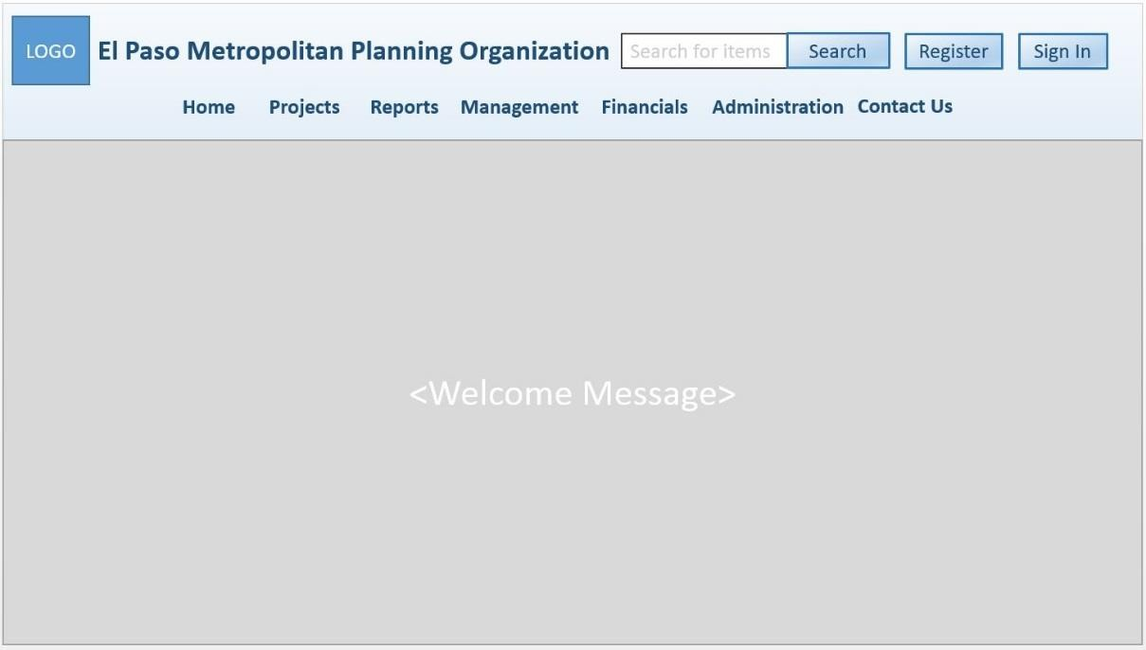

Figure 7: Welcome Page

**3.1.1.5. Projects Page**

[SRS 8] The Projects page shall contain the following elements as shown in Figure 8:

a. The appropriate heading dependent on log-in status b. Menu bar

c. Project mouseover menu d. Project search menu

e. Project result area

f. Map legend with an orange map marker labeled as “Planning”, a blue map marker labeled as “Underway”, a red map marker labeled as “Near Completion”, and a green map marker labeled as “Completed”

g. Button labeled as “Tabular view”.

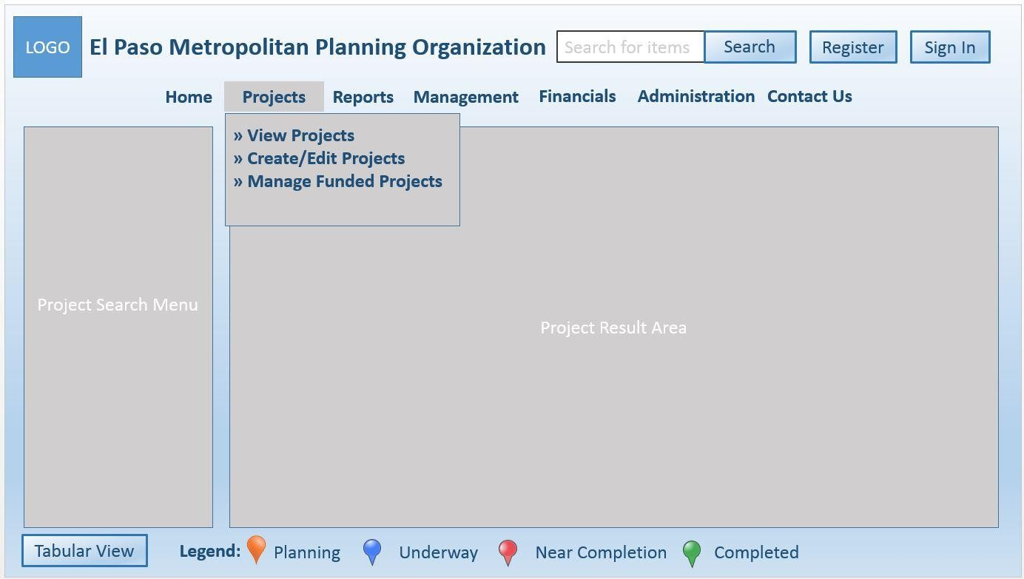

|  |  |  |  |
| --- | --- | --- | --- |
| Software Requirements Specification |  | Date  **2/18/2016 5:20 PM** | Page  **16** |

Figure 8: Projects Page

**3.1.1.5.1. View Projects Page**

[SRS 9] The Project Result Area shall display a map of El Paso County and Doña Ana County with all projects, which can be represented on a map, marked with map markers by default upon landing the Projects page

as shown in Figure 9.

Figure 9: View Projects Page

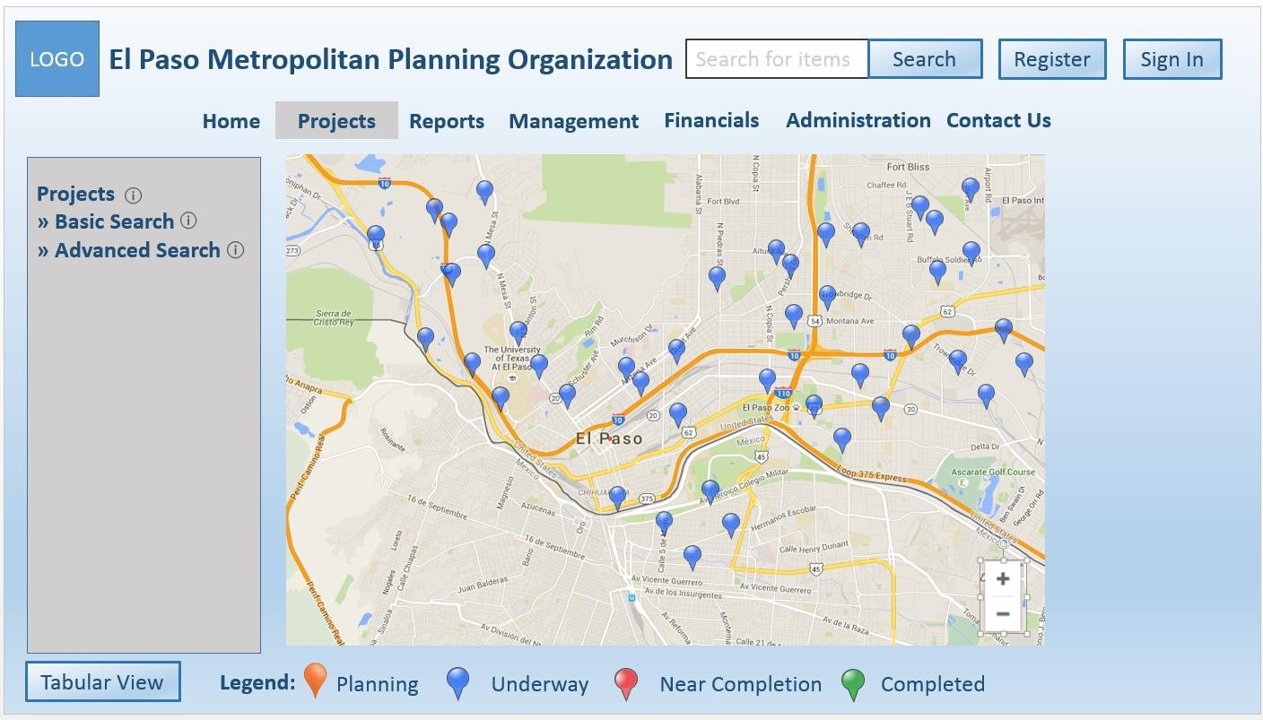

[SRS 10] The search result shall be displayed on the map as shown in Figure 9 by default. [SRS 11] The Project Result Area shall display a zoom in and zoom out button on the map. [SRS 12] The tabular view shall contain the following elements as shown in Figure 10:

a. ID

b. Project title

c. Project description d. Termini

e. Network

f. Total Project Cost g. Sponsor

h. YOE

i. File icon button for each project j. Sort button for the ID element

k. Button labeled as “Map view”.

|  |  |  |  |
| --- | --- | --- | --- |
| Software Requirements Specification |  | Date  **2/18/2016 5:20 PM** | Page  **17** |

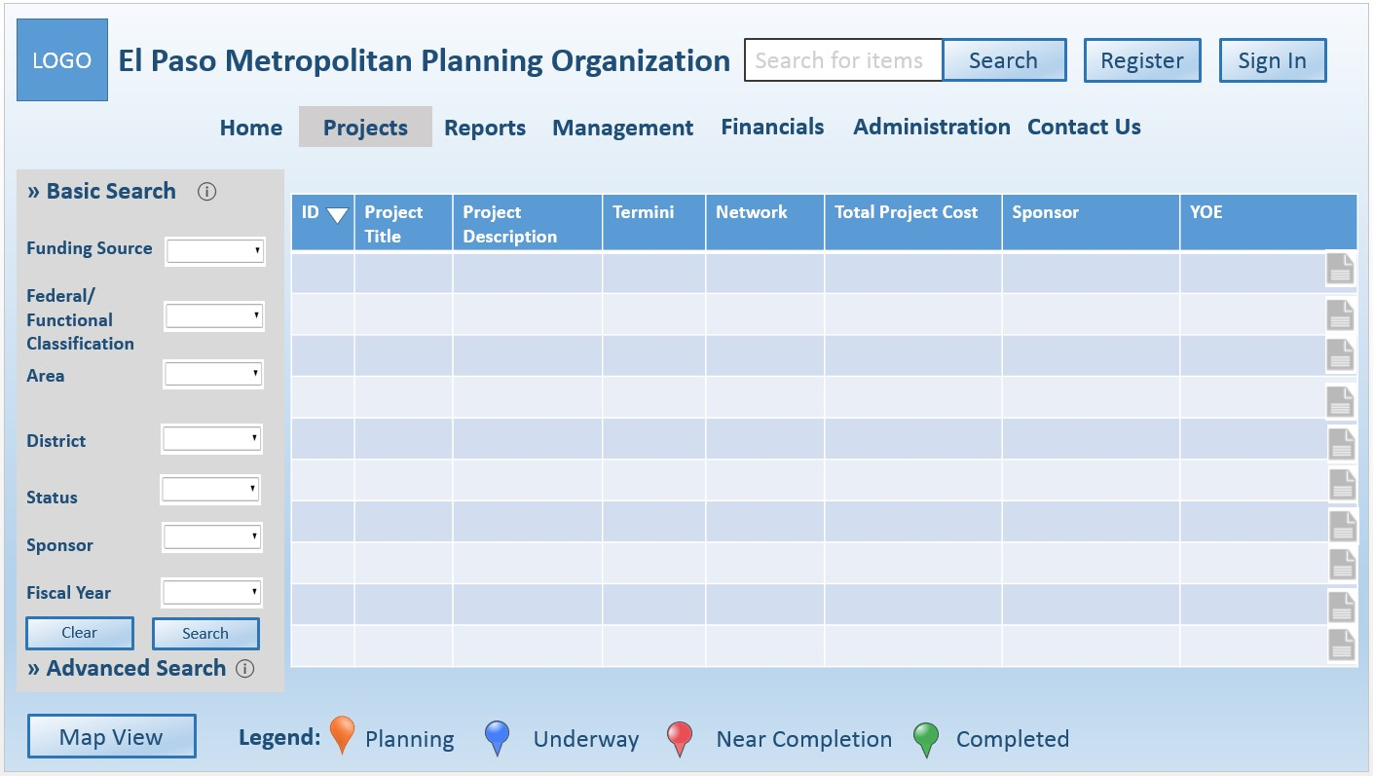

Figure 10: Search Result in Tabular View

[SRS 13] Users shall be able to zoom in and zoom out on the map.

[SRS 14] The Project Mouseover Menu shall contain the following three options:

a. View Projects

b. Create/Edit Projects

c. Manage Funded Projects.

[SRS 15] The Project Search Menu shall contain two options for searching for projects as shown in Figure 9:

a. Basic search

b. Advanced search.

[SRS 16] The Basic Search shall display the following elements as shown in Figure 11:

a. Drop down list box labeled as “Funding Source”

b. Drop down list box labeled as “Federal/Functional Classification”

c. Drop down list box labeled as “Area”

d. Drop down list box labeled as “District”

e. Drop down list box labeled as “Status”

f. Drop down list box labeled as “Sponsor”

g. Drop down list box labeled as “Fiscal Year”

h. Button labeled as “Clear”

i. Button labeled as “Search”

j. Information icon about Basic Search.

|  |  |  |  |
| --- | --- | --- | --- |
| Software Requirements Specification |  | Date  **2/18/2016 5:20 PM** | Page  **18** |

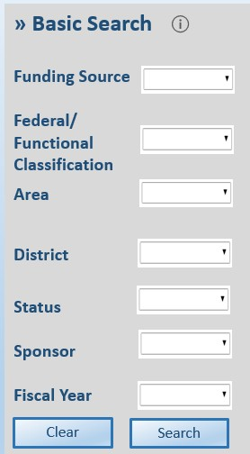

Figure 11: Basic Search

[SRS 17] The Advanced Search shall allow users to locate projects by:

a. project ID

b. keyword.

[SRS 18] The Advanced Search shall display the following elements as shown in Figure 12:

a. Text box labeled as “Project ID”

b. Text box labeled as “Keyword”

c. Information icon about Advanced Search d. Button labeled as “Clear”

e. Button labeled as “Search”.

Figure 12: Advanced Search

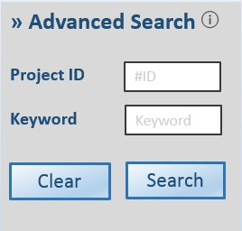

[SRS 19] The Project Information pop-up window shall display the following elements as shown in Figure 13:

a. Tab-control window labeled “Basic Information”

b. Tab-control window labeled “Detailed Information”

c. File icon button d. Close button.

[SRS 20] The Tab-control window labeled “Basic Information” shall display information about a selected

project as described in Table 5 and a file icon button.

[SRS 21] The Tab-control window labeled “Detailed Information” shall display information about a selected

project as described in Table 6 and a file icon button.

|  |  |  |  |
| --- | --- | --- | --- |
| Software Requirements Specification |  | Date  **2/18/2016 5:20 PM** | Page  **19** |

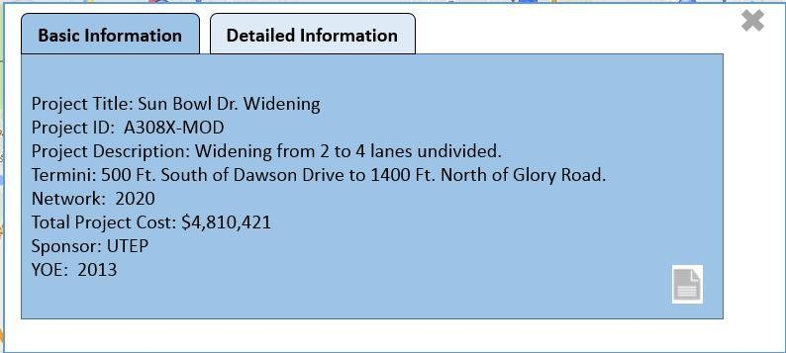

Figure 13: Project Information Pop-Up Window

Table 5: Basic Project Information

|  |
| --- |
| Basic Information |
| Project Title |
| Project ID |
| Project Description |
| Termini |
| Network |
| Total Project Cost |
| Sponsor |
| YOE |

Table 6: Detailed Project Information

**Detailed Information**

MPO will provide the information.

**3.1.1.5.2. Create/Edit Project Page**

[SRS 22] The Workflow Status Bar shall include the following elements as shown in Figure 14. a. Label that displays “Under Preparation”

b. Label that displays “Under Review”

c. Label that displays “Modification Required” d. Label that displays “Ready for Submission” e. Label that displays “Submitted to TPB”

Figure 14: Workflow Status Bar



[SRS 23] The Create/Edit Project page shall display the following elements as shown in Figure 15. a. Post-login Heading

b. Menu bar

c. Workflow Status bar d. Projects search menu e. Projects result area

|  |  |  |  |
| --- | --- | --- | --- |
| Software Requirements Specification |  | Date  **2/18/2016 5:20 PM** | Page  **20** |

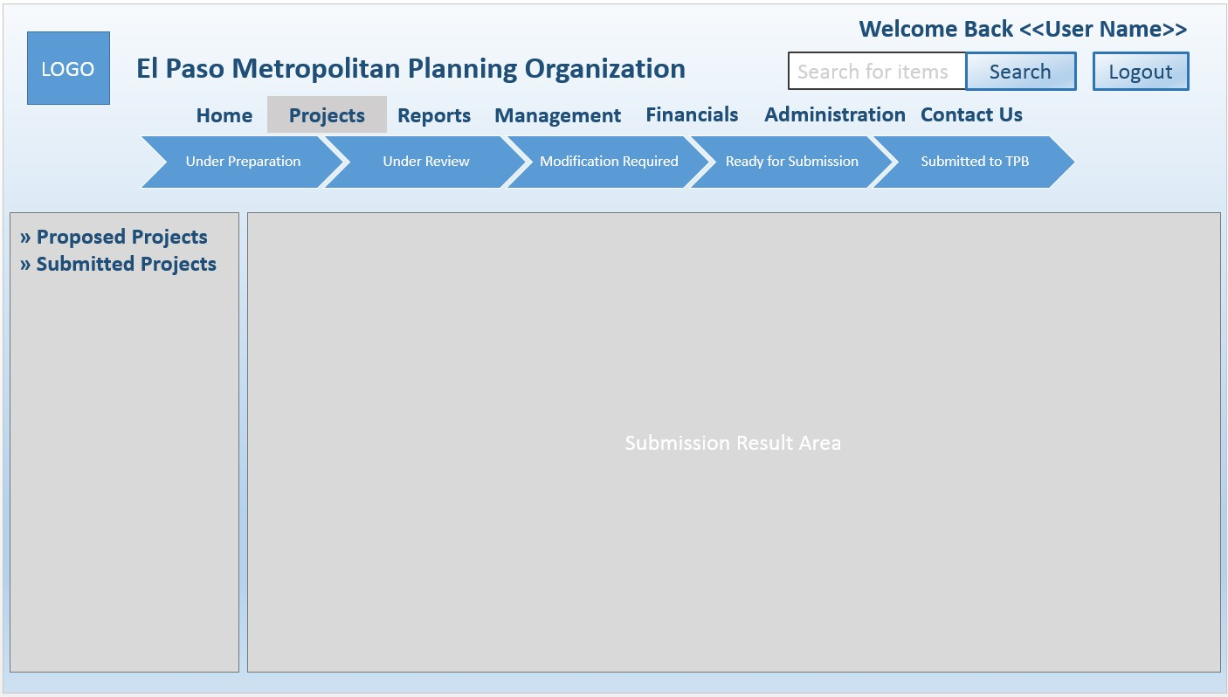

Figure 15: Create/Edit Project Page

[SRS 24] The Projects Search menu shall contain the following options:

a. Proposed Projects

b. Submitted Projects.

[SRS 25] The Proposed Projects search menu shall include the following as shown in Figure 16:

a. Text input box labeled as “Project ID” b. Text input box labeled as “Keyword”. c. Button labeled as “Clear”

d. Button labeled as “Search”

e. Information icon about proposed project.

[SRS 26] The “Proposed Projects” Result Area shall display a table with the following elements as shown in

Figure 16:

a. Column labeled as “ID”

b. Column labeled as “Fiscal Year”

c. Column labeled as “Project Type”

d. Column labeled as “Status”

e. Column labeled as “Action” with a button labeled as “Edit” and a button labeled as

“Withdraw”

f. Sort button for the “ID” column

g. Sort button for the “Fiscal Year” column h. Sort button for the “Project Type” column i. Sort button for the “Status” column

j. Add button.

|  |  |  |  |
| --- | --- | --- | --- |
| Software Requirements Specification |  | Date  **2/18/2016 5:20 PM** | Page  **21** |

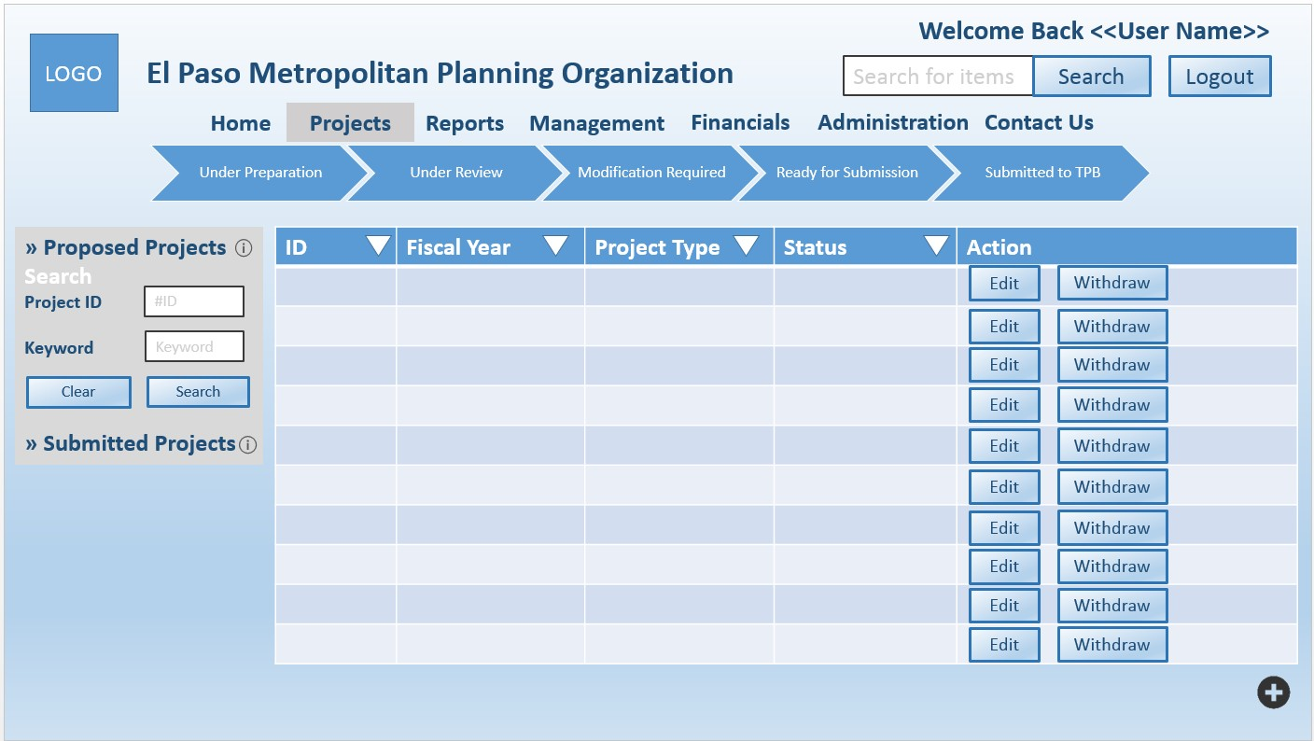

Figure 16: New Submissions Page

[SRS 27] The Submitted Project search menu shall include the following as shown in Figure 17:

a. Text input box labeled as “Project ID” b. Text input box labeled as “Keyword”. c. Button labeled as “Clear”

d. Button labeled as “Search”

e. Information icon about pending submissions

[SRS 28] The “Submitted Projects” Result Area shall display a table with the following elements as shown in

Figure 17:

a. Column labeled as “ID”

b. Column labeled as “Fiscal Year”

c. Column labeled as “Project Type”

d. Column labeled as “Status”

e. Column labeled as “Action” with a button labeled as “View” and a button labeled as

“Withdraw”

f. Sort button for the “ID” column

g. Sort button for the “Fiscal Year” column h. Sort button for the “Project Type” column i. Sort button for the “Status” column.

|  |  |  |  |
| --- | --- | --- | --- |
| Software Requirements Specification |  | Date  **2/18/2016 5:20 PM** | Page  **22** |

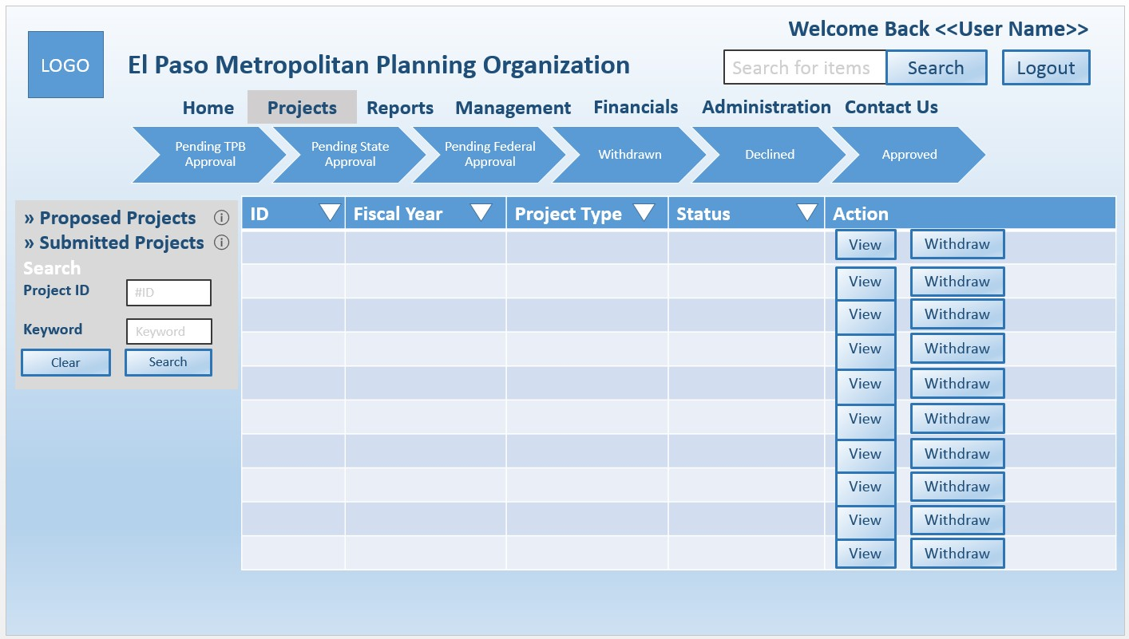

Figure 17: Submitted Projects Page

[SRS 29] The withdraw pop up window shall display the following as shown in Figure 18:

a. Label that displays “Are you sure you would like to withdraw the proposed project?”

b. Button labeled as “Withdraw”

c. Button labeled as “Cancel”.

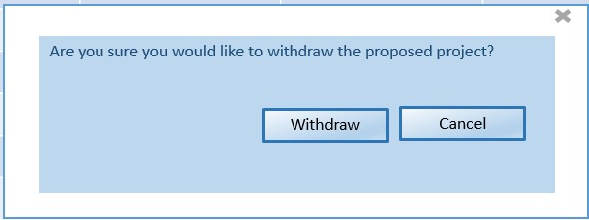

Figure 18: Withdraw Popup Window

[SRS 30] A proposed project shall include the following subsections as shown in Figure 19 to Figure 40:

a. Label that displays “APP = Approved”

b. Label that displays “MOD = modification required”

c. Project Creation

d. General Information e. Fund Project

f. Project Information g. Transit Information

h. Sponsoring Agency Contact Information i. State Agency Contact Information

j. Local Agency Contact Information

k. Project Selection Information – Phase 2

|  |  |  |  |
| --- | --- | --- | --- |
| Software Requirements Specification |  | Date  **2/18/2016 5:20 PM** | Page  **23** |

l. Project Selection Information – Phase 2.1 m. Project Selection Information – Phase 2.2

n. Project Selection Information – Phase 2.3 A-C o. Project Readiness Elements Basic Information p. Project Readiness Sub-Elements

q. Review

r. Project Phases Information

s. Total Project Cost Information t. CMAQ Analysis Information

u. Project Funding Basic Information

v. Project Funding Detailed Information w. Signature

x. Button labeled as “Save”.

y. Button labeled as “Save and Exit”.

z. Button labeled as “Back”.

aa. Button labeled as “Submit for MPO Staff Review”.

bb. Button labeled as “Submit for TPB Approval”.

[SRS 31] The Project Creation subsection shall include the following elements as shown in Figure 19:

a. Label that displays “Project Creation”

b. Information icon about Project Creation

c. Label that displays “What kind of project would you be creating?”

d. Radio button labeled as “A new submission”

e. Radio button labeled as “A new submission based on a previous submission”

f. Text input box labeled as “MPO ID# or CSJ/CS#”.A radio button labeled as “Resubmission”

g. Text input box labeled as “MPO ID# or CSJ/CS#”

h. Text input box labeled as “Revision Description”

i. Text input box labeled as “Review Comments”

j. Radio button labeled as “APP”

k. Radio button labeled as “MOD”

[SRS 32] The General Information subsection shall include the following elements as shown in Figure 19:

a. Label that displays “General Information”

b. Information icon about General Information c. Text input box labeled as “Project Name”

d. Text input box labeled as “Project Description”

e. Text input box labeled as “Limit From”

f. Text input box labeled as “Limit To”

g. Text input box labeled as “Scope of Work”.

h. Text input box labeled as “Review Comments”

i. Radio button labeled as “APP”

j. Radio button labeled as “MOD”

[SRS 33] The Fund Project subsection shall include the following elements as shown in Figure 19:

a. Label that displays “Fund Project (MPO Staff)”

b. Information icon about Fund Project (MPO Staff)

c. Label that displays “What kind of funded project is it?”

d. Radio button labeled as “Highway_Roadway Fund Project (FHWA/State & Local Funds)”

e. Radio button labeled as “Transit Fund Project (FTA/State & Local Funds)”.

f. Text input box labeled as “Review Comments”

g. Radio button labeled as “APP”

h. Radio button labeled as “MOD”.

[SRS 34] The Project Information subsection shall include the following elements as shown in Figure 20 and

Figure 21:

a. Label that displays “Project Information”

|  |  |  |  |
| --- | --- | --- | --- |
| Software Requirements Specification |  | Date  **2/18/2016 5:20 PM** | Page  **24** |

b. Information icon about Project Information

c. Drop down list box labeled as “Federal Fiscal Year”

d. Drop down list box labeled as “Network Year”

e. Label that displays “Does the project include a ON-system and/or OFF-system road?”

f. Radio button labeled as “ON-State System Road”

g. Radio button labeled as “OFF-State System Road”

h. Label that displays “Is the project a capacity project (additional through lanes)?”

i. Radio button labeled as “Yes” for the label

j. Radio button labeled as “No”

k. Text input box labeled as “Number of Existing Lanes”

l. Text input box labeled as “Number of Projected Lanes”

m. Text input box labeled as “Number of Miles”

n. Text input box labeled as “Highway_roadway Name”

o. Text input box labeled as “Project Type”

p. Text input box labeled as “Federal Functional Classification”

q. Text input box labeled as “DOT District”

r. Text input box labeled as “County”

s. Text input box labeled as “City”

t. Text input box labeled as “Project Region”

u. Text input box labeled as “Review Comments”

v. Radio button labeled as “APP”

w. Radio button labeled as “MOD”.

[SRS 35] The Transit Information subsection shall include the following elements as shown in Figure 21:

a. Label that displays “Transit Information”

b. Information icon about Transit Information c. Text input box labeled as “Section 309 ID”

d. Text input box labeled as “Apportionment Year”

e. Text input box labeled as “TDC Award Amount”

f. Drop down list box labeled as “TDC Award Date” g. Text input box labeled as “TDC Award Requested” h. Label that displays “What is the project type?”

i. Radio button labeled as “Capital”

j. Radio button labeled as “Planning”

k. Radio button labeled as “Operating”

l. Radio button labeled as “Administration”.

m. Text input box labeled as “Review Comments”

n. Radio button labeled as “APP”

o. Radio button labeled as “MOD”.

[SRS 36] The Sponsoring Agency Contact Information subsection shall include the following elements as shown in Figure 22:

a. Label that displays “Sponsoring Agency Contact Information”

b. Information icon about Sponsoring Agency Contact Information for the sponsoring agency c. Text input box labeled as “Organization Name” for the sponsoring agency

d. Text input box labeled as “Department Name” for the sponsoring agency

e. Text input box labeled as “Contact Person’s First Name” for the sponsoring agency

f. Text input box labeled as “Contact Person’s Middle Initial Name” for the sponsoring agency

g. Text input box labeled as “Contact Person’s Last Name” for the sponsoring agency

h. Text input box labeled as “Contact Person’s Position Title” for the sponsoring agency

i. Text input box labeled as “Work Contact Number” for the sponsoring agency

j. Text input box labeled as “Department Contact Number” for the sponsoring agency

k. Text input box labeled as “Email” for the sponsoring agency.

l. Text input box labeled as “Review Comments”

m. Radio button labeled as “APP”

n. Radio button labeled as “MOD”.

|  |  |  |  |
| --- | --- | --- | --- |
| Software Requirements Specification |  | Date  **2/18/2016 5:20 PM** | Page  **25** |

[SRS 37] The State Agency Contact Information subsection shall include the following elements as shown in

Figure 22 and Figure 23:

a. Label that displays “State Agency Contact Information”

b. Information icon about State Agency Contact Information for the state agency c. Text input box labeled as “Organization Name” for the state agency

d. Text input box labeled as “Department Name” for the state agency

e. Text input box labeled as “Contact Person’s First Name” for the state agency

f. Text input box labeled as “Contact Person’s Middle Initial Name” for the state agency g. Text input box labeled as “Contact Person’s Last Name” for the state agency

h. Text input box labeled as “Contact Person’s Position Title” for the state agency

i. Text input box labeled as “Work Contact Number” for the state agency

j. Text input box labeled as “Department Contact Number” for the state agency

k. Text input box labeled as “Email” for the state agency l. Text input box labeled as “Review Comments”

m. Radio button labeled as “APP”

n. Radio button labeled as “MOD”.

[SRS 38] The Local Agency Contact Information subsection shall include the following elements as shown in

Figure 23:

a. Label that displays “Local Agency Contact Information”

b. Information icon about Local Agency Contact Information for the local agency c. Text input box labeled as “Organization Name” for the local agency

d. Text input box labeled as “Department Name” for the local agency

e. Text input box labeled as “Contact Person’s First Name” for the local agency

f. Text input box labeled as “Contact Person’s Middle Initial Name” for the local agency

g. Text input box labeled as “Contact Person’s Last Name” for the local agency

h. Text input box labeled as “Contact Person’s Position Title” for the local agency

i. Text input box labeled as “Work Contact Number” for the local agency

j. Text input box labeled as “Department Contact Number” for the local agency

k. Text input box labeled as “Email” for the local agency

l. Text input box labeled as “Review Comments”

m. Radio button labeled as “APP”

n. Radio button labeled as “MOD”.

[SRS 39] The Project Selection Information Phase 2 subsection shall include the following elements as shown in Figure 24 to Figure 27:

a. Label that displays “Project Selection Information – Phase 2”

b. Information icon about Project Selection Information – Phase 2

c. Label that displays “1. Does the project improve safety in areas with high number of

crashes?”

d. Radio button labeled as “Yes, please provide the attachment of the number of crashes in the areas.”

e. Text input button labeled as “File Attachment”

f. Button labeled as “Upload File”

g. Radio button labeled as “No”

h. Label that displays “2. Does the project improve crossing, signalizations, traffic calming, etc. to promote safety?”

i. Radio button labeled as “Yes, please provide the number of crossings, signalization, etc. and the name of the streets it will improve.”

j. Text input button labeled as “No. of Crossings”

k. Text input button labeled as “Street Names”

l. Radio button labeled as “No”

m. Label that displays “3. Is this project identified on a Comprehensive Plan?”

n. Radio button labeled as “Yes, please provide the name of the Comprehensive Plan.”

o. Text input button labeled as “Name of the Comprehensive Plan”

|  |  |  |  |
| --- | --- | --- | --- |
| Software Requirements Specification |  | Date  **2/18/2016 5:20 PM** | Page  **26** |

p. Radio button labeled as “No”

q. Label that displays “4. Does it implement a planned facility/transit service/program in an active Master Plan, to include major thoroughfare plan or other related transportation plan (not older than 5 years) adopted by the sponsor’s governing body?”

r. Radio button labeled as “Yes, please provide the name of the Master Plan.”

s. Text input button labeled as “Name of the Master Plan”

t. Radio button labeled as “No”

u. Label that displays “5. Does the project have feasibility studies supporting project proposal?”

v. Radio button labeled as “Yes, please provide the attachment of the feasibility study.”

w. Text input button labeled as “File Attachment”

x. Button labeled as “Upload File”

y. Radio button labeled as “No”

z. Label that displays “6. Does it provide a grade-separated crossing under or over a barrier such as canal, arroyo, railroads, and roadways?”

aa. Radio button labeled as “Yes, please provide the name/area of barrier.”

bb. Text input button labeled as “Name/area of barrier”

cc. Radio button labeled as “No”

dd. Label that displays “7. Does it pave unpaved roads (reducing PM-10)?”

ee. Radio button labeled as “Yes, please provide the name of the unpaved roads.”

ff. Text input button labeled as “Name of the unpaved roads”

gg. Radio button labeled as “No”

hh. Label that displays “8. Does it help reduce other emissions to improve air quality?”

ii. Radio button labeled as “Yes, please provide the supporting data.”

jj. Text input button labeled as “File Attachment”

kk. Button labeled as “Upload File”

ll. Radio button labeled as “No”

mm. Label that displays “9. Does it have adequate local support from the community?”

nn. Radio button labeled as “Yes, please provide the local support letter.”

oo. Text input button labeled as “File Attachment”

pp. Button labeled as “Upload File”

qq. Radio button labeled as “No”

rr. Label that displays “10. Does it have adequate local support from a governmental body?”

ss. Radio button labeled as “Yes, please provide the date and time of council meeting or resolution.”

tt. Text input button labeled as “Date and Time of Council Meeting”

uu. Text input button labeled as “File Attachment”

vv. Button labeled as “Upload File”

ww. Radio button labeled as “No”

xx. Label that displays “11. Does it have adequate local support from school(s), school district(s), university(ies), and/or college(s)?”

yy. Radio button labeled as “Yes, please provide the local support letter.”

zz. Text input button labeled as “File Attachment”

aaa. Button labeled as “Upload File”

bbb. Radio button labeled as “No”

ccc. Label that displays “12. Does it provide direct connectivity to:”

ddd. Check box labeled as “Residential Areas” eee. Check box labeled as “Industrial Areas” fff. Check box labeled as “Commercial Areas” ggg. Check box labeled as “Bicycle Paths”

hhh. Check box labeled as “Rural Areas (including Agricultural Areas)”

iii. Check box labeled as “Pedestrian Paths (sidewalks)”

jjj. Check box labeled as “Transit (bus stops)”

kkk. Check box labeled as “Recreational Activities”

lll. Label that displays “13. Does it promote sustainability by:”

mmm. Check box labeled as “Land use (supported by comprehensive plan or studies)”

nnn. Check box labeled as “Promoting Economic Development”

|  |  |  |  |
| --- | --- | --- | --- |
| Software Requirements Specification |  | Date  **2/18/2016 5:20 PM** | Page  **27** |

ooo. Check box labeled as “Removing pedestrian and/or bicycle barriers”

ppp.Text input box labeled as “Review Comments”

qqq.Radio button labeled as “APP”

rrr. Radio button labeled as “MOD”.

[SRS 40] The Project Selection Information Phase 2.1 subsection shall include the following elements as shown in Figure 27:

a. Label that displays “Project Selection Information – Phase 2.1”

b. Information icon about Project Selection Information – Phase 2.1 c. Label that displays “1. Does it fulfil MAP 21 National Goals?”

d. Check box labeled as “Safety”

e. Check box labeled as “Infrastructure Condition”

f. Check box labeled as “Congestion Reduction”

g. Check box labeled as “System Reliability”

h. Check box labeled as “Freight Movement and Economic Vitality”

i. Check box labeled as “Environmental Sustainability”

j. Text input box labeled as “Review Comments”

k. Radio button labeled as “APP”

l. Radio button labeled as “MOD”.

[SRS 41] The Project Selection Information Phase 2.2 subsection shall include the following elements as shown in Figure 27:

a. Label that displays “Project Selection Information – Phase 2.2”

b. Information icon about Project Selection Information – Phase 2.2 c. Label that displays “1. Does it satisfy CMP Strategies?”

d. Check box labeled as “Travel Demand Management Strategies”

e. Check box labeled as “Traffic Operations Strategies”

f. Check box labeled as “Public Transportation Strategies”

g. Check box labeled as “Road Capacity Strategies”

h. Check box labeled as “Non-CMP Strategies”

i. Text input box labeled as “Review Comments”

j. Radio button labeled as “APP”

k. Radio button labeled as “MOD”.

[SRS 42] The Project Selection Information Phase 2.3 A-C subsection shall include the following elements as shown in Figure 28:

a. Label that displays “Project Selection Information – Phase 2.3 A-C”

b. Information icon about Project Selection Information – Phase 2.3 A-C

c. Text input box labeled as “Sponsor Investment to Construction Cost”

d. Text input box labeled as “Local/State Match Commitment to Federal Funding”

e. Text input box labeled as “Phase Investment to E and/or ROW phase”

f. Text input box labeled as “Review Comments”

g. Radio button labeled as “APP”

h. Radio button labeled as “MOD”.

[SRS 43] The Project Readiness Elements Information subsection shall include the following elements as shown in Figure 28:

a. Label that displays “Project Readiness Elements Basic Information”

b. Information icon about Project Readiness Elements Basic Information c. Label that displays “What kind of project is it?”

d. Radio button labeled as “Construction Project”

e. Radio button labeled as “Non-Construction Project”

f. Radio button labeled as “FTA Transfer Project”

g. Radio button labeled as “Other”

h. Text input box labeled as “Review Comments”

i. Radio button labeled as “APP”

|  |  |  |  |
| --- | --- | --- | --- |
| Software Requirements Specification |  | Date  **2/18/2016 5:20 PM** | Page  **28** |

j. Radio button labeled as “MOD”.

[SRS 44] The Project Readiness Sub-elements subsection shall include the following elements as shown in

Figure 28 to Figure 35, Table 7, and

a. Text input box labeled as “Review Comments” for each subsection

b. Radio button labeled as “APP” for each subsection

c. Radio button labeled as “MOD” for each subsection.

[SRS 45] The Review section shall include the following elements as shown in Figure 37:

a. Label that displays “Review”

b. Information icon about review

c. Label that displays “Have the above dates been reviewed by TxDOT or NMDOT?”

d. Radio button labeled as “Yes”

e. Drop down box labeled as “Date Reviewed”

f. Text input box labeled as “Reviewed by”

g. Text input box labeled as “Agency”

h. Radio button labeled as “No”

i. Radio button labeled as “N/A”

j. Text input box labeled as “Review Comments”

k. Radio button labeled as “APP”

l. Radio button labeled as “MOD”.

[SRS 46] The Project Phases Information subsection shall include the following elements as shown in Figure 37 and Figure 38:

a. Label that displays “Project Phases Information”

b. Information icon about project phases information

c. Label that displays “Will you be applying for funding for project in the “FHWA to FTA

transfer” phase?”

d. Radio button labeled as “Yes” for the label as described in c

e. Radio button labeled as “No” for the label as described in c

f. Label that displays “Will you be applying for funding for project in the “construction”

phase?”

g. Radio button labeled as “Yes” for the label as described in f

h. Radio button labeled as “No” for the label as described in f

i. Label that displays “Will you be applying for funding for project in the “preliminary engineering” phase?”

j. Radio button labeled as “Yes” for the label as described in i k. Radio button labeled as “No” for the label as described in i

l. Label that displays “Will you be applying for funding for project in the “engineering” phase?”

m. Radio button labeled as “Yes” for the label as described in l

n. Radio button labeled as “No” for the label as described in l

o. Label that displays “Will you be applying for funding for project in the “environmental document” phase?”

p. Radio button labeled as “Yes” for the label as described in o

q. Radio button labeled as “No” for the label as described in o

r. Label that displays “Will you be applying for funding for project in the “right of way”

phase?”

s. Radio button labeled as “Yes” for the label as described in r

t. Radio button labeled as “No” for the label as described in r

u. Label that displays “Will you be applying for funding for project in the “right of way acquired” phase?”

v. Radio button labeled as “Yes” for the label as described in u

w. Radio button labeled as “No” for the label as described in u

x. Label that displays “Will you be applying for funding for project in the “right of way utilities completed” phase?”

y. Radio button labeled as “Yes” for the label as described in x

|  |  |  |  |
| --- | --- | --- | --- |
| Software Requirements Specification |  | Date  **2/18/2016 5:20 PM** | Page  **29** |

z. Radio button labeled as “No” for the label as described in x.

aa. Text input box labeled as “Review Comments”

bb. Radio button labeled as “APP”

cc. Radio button labeled as “MOD”.

[SRS 47] The Total Project Cost Information subsection shall include the following elements as shown in

Figure 39:

a. Label that displays “Total Project Cost Information”

b. Information icon about total project cost

c. Text input box labeled as “Non-Construction Project”

d. Text input button labeled as “File Attachment” for non-construction project e. Button labeled as “Upload File” for non-construction project

f. Text input box labeled as “Construction”

g. Text input button labeled as “File Attachment” for construction

h. Button labeled as “Upload File” for construction

i. Text input box labeled as “Construction Engineering” for construction engineering

j. Text input button labeled as “File Attachment” for construction engineering

k. Button labeled as “Upload File” for construction engineering

l. Text input box labeled as “Contingencies”

m. Text input button labeled as “File Attachment” for contingencies

n. Button labeled as “Upload File” for contingencies

o. Text input box labeled as “Potential Change Order” for potential change order

p. Text input button labeled as “File Attachment” for potential change order q. Button labeled as “Upload File” for potential change order

r. Text input box labeled as “Preliminary Engineering”

s. Text input button labeled as “File Attachment” for preliminary engineering

t. Button labeled as “Upload File” for preliminary engineering

u. Text input box labeled as “Right of Way”

v. Text input button labeled as “File Attachment” for right of way

w. Button labeled as “Upload File” for right of way x. Text input box labeled as “FTA Transfer”

y. Text input button labeled as “File Attachment” for FTA transfer z. Button labeled as “Upload File” for FTA transfer

aa. Label that displays as “Total Project Cost”

bb. Label that displays the amount of the total project cost cc. Text input box labeled as “Review Comments”

dd. Radio button labeled as “APP”

ee. Radio button labeled as “MOD”.

[SRS 48] The CMAQ Analysis Information subsection shall include the following elements as shown in Figure

39:

a. Label that displays “CMAQ Analysis Information”

b. Information icon about CMAQ Analysis

c. Text input box labeled as “VOC (Kgs/day)”

d. Text input box labeled as “CO (Kgs/day)”

e. Text input box labeled as “NOX (Kgs/day)”

f. Text input box labeled as “Prepared By”

g. Label that displays “Please provide air quality analysis.”

h. Text input button labeled as “File Attachment”

i. Button labeled as “Upload File”

j. Text input box labeled as “Review Comments”

k. Radio button labeled as “APP”

l. Radio button labeled as “MOD”.

[SRS 49] The Project Funding Basic Information subsection shall include the following elements as shown in

Figure 40:

a. Label that displays “Project Funding Basic Information”

|  |  |  |  |
| --- | --- | --- | --- |
| Software Requirements Specification |  | Date  **2/18/2016 5:20 PM** | Page  **30** |

b. Information icon about project funding basic information

c. Label that displays “Would you be requesting for MPO Funds?”

d. Radio button labeled as “Yes”

e. Radio button labeled as “No”.

f. Text input box labeled as “Review Comments”

g. Radio button labeled as “APP”

h. Radio button labeled as “MOD”.

[SRS 50] The Project Funding Detailed Information subsection shall include the following elements as shown in Figure 40:

a. Label that displays “Project Funding Detailed Information”

b. Information icon about project funding basic information c. Drop down list box labeled as “Funding Source”

d. Text input box labeled as “Federal Share”

e. Text input box labeled as “State Share”

f. Text input box labeled as “Local Share”

g. Text input box labeled as “Local Contribution”

h. Label that displays the summation of the federal share, state share, local share, and local contribution as specified in text input boxes d, e, f, and g

i. Add button

j. Label that displays “Total Funding by Share”

k. Label that displays the summation of all federal shares specified in this section l. Label that displays the summation of all state shares specified in this section

m. Label that displays the summation of all local shares specified in this section

n. Label that displays the summation of all local contributions specified in this section

o. Label that displays the summation of all federal shares, state shares, local shares, and local contributions specified in this section

p. Label that displays “YOE Cost”

q. Label that displays the YOE cost.

r. Text input box labeled as “Review Comments”

s. Radio button labeled as “APP”

t. Radio button labeled as “MOD”.

[SRS 51] The Signature subsection shall include the following elements as shown in Figure 40:

a. Label that displays “By signing this application, you certify that the information provided in

this application is true and correct to the best of your knowledge and belief”

b. Text input box labeled as “Print Name”

c. Text input box labeled as “Title”

d. Text input box labeled as “Authorized Signature”

e. Text input box labeled as “Date”

f. Text input box labeled as “Review Comments”

g. Radio button labeled as “APP”

h. Radio button labeled as “MOD”.

Table 7: Project Readiness Sub-Elements

|  |  |  |  |  |  |  |
| --- | --- | --- | --- | --- | --- | --- |
| Project  Readiness  Sub-element | Information  Icon about the Project Readiness  Sub-element | Calendar Drop  Down Box labeled as “Estimated Start Date” | Calendar Drop  Down Box labeled as “Estimated Finish Date” | % Progress  Drop Down Box labeled as “% Progress” | Responsible  Agency Drop Down Box labeled as “Responsible Agency” | Text Input Box  labeled as  “Comments” |
| Schematic | X | X | X | X | X | X |
| Environment  al Document | X | X | X | X | X | X |

|  |  |  |  |
| --- | --- | --- | --- |
| Software Requirements Specification |  | Date  **2/18/2016 5:20 PM** | Page  **31** |

|  |  |  |  |  |  |  |
| --- | --- | --- | --- | --- | --- | --- |
| ROW  Map(s) | X | X | X | X | X | X |
| ROW | X | X | X | X | X | X |
| Utilities | X | X | X | X | X | X |
| PS&E | X | X | X | X | X | X |
| Public  Involvement | X | X | X | X | X | X |
| District  Review | X | X | X | X | X | X |
| Agreement  (LPFA) | X | X | X | X | X | X |
| Procurement  Process | X | X | X | X | X | X |
| Let Date | X | X |  |  |  | X |
| Performance  End Date | X | X |  |  |  | X |
| Construction | X | X | X | X | X | X |
| Execution  (usually  Transit) | X | X | X | X | X | X |
| Active  (usually  Transit) | X | X | X | X | X | X |
| Contract  (usually  Transit) | X | X | X | X | X | X |
| Delivery  (usually  Transit) | X | X | X | X | X | X |
| Other | X | X | X | X | X | X |

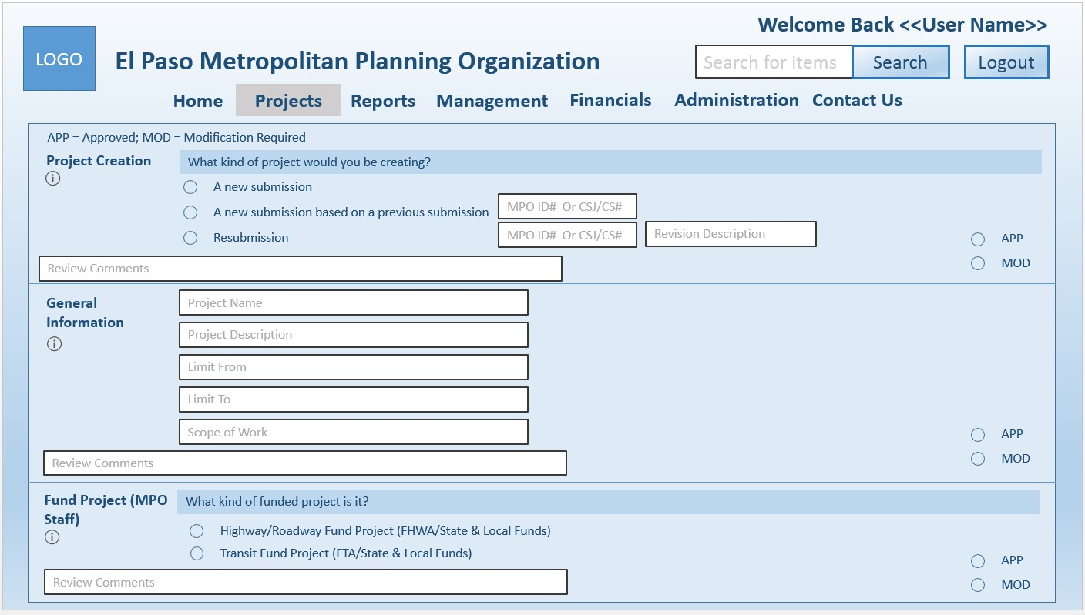

Figure 19: Submission Form 1

|  |  |  |  |
| --- | --- | --- | --- |
| Software Requirements Specification |  | Date  **2/18/2016 5:20 PM** | Page  **32** |

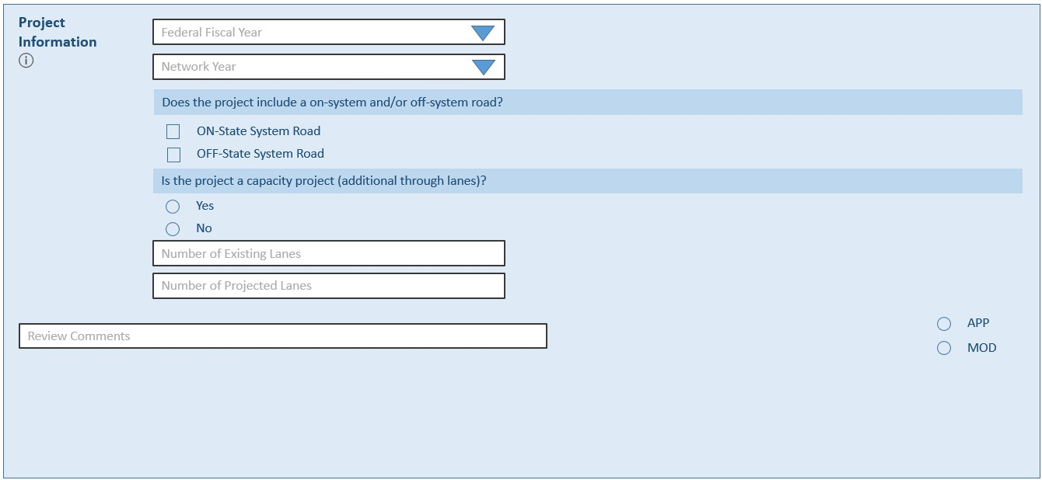

Figure 20: Submission Form 2

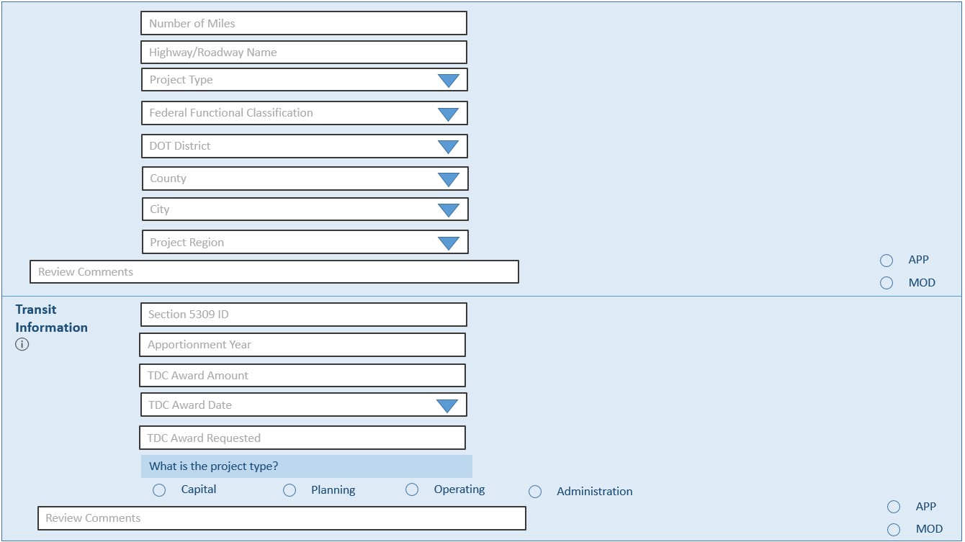

Figure 21: Submission Form 3

|  |  |  |  |
| --- | --- | --- | --- |
| Software Requirements Specification |  | Date  **2/18/2016 5:20 PM** | Page  **33** |

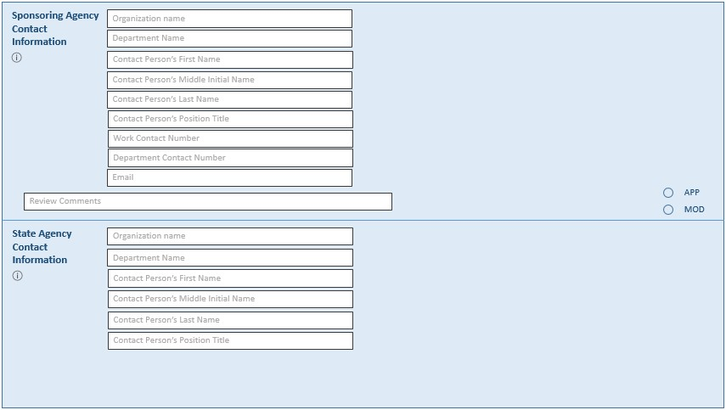

Figure 22: Submission Form 4

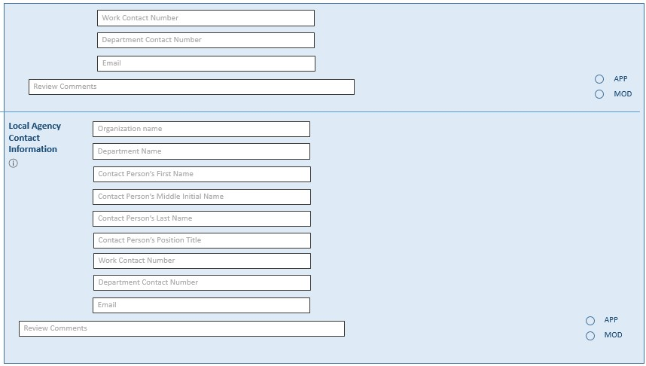

Figure 23: Submission Form 5

|  |  |  |  |
| --- | --- | --- | --- |
| Software Requirements Specification |  | Date  **2/18/2016 5:20 PM** | Page  **34** |

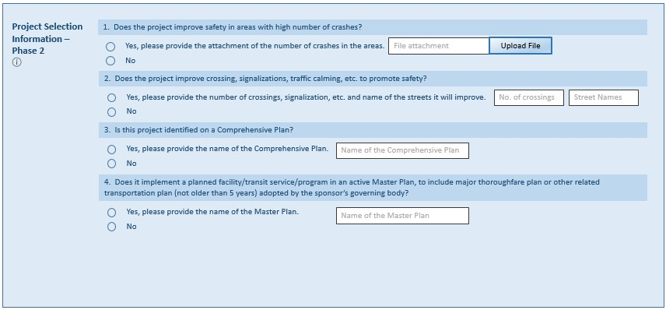

Figure 24: Submission Form 6

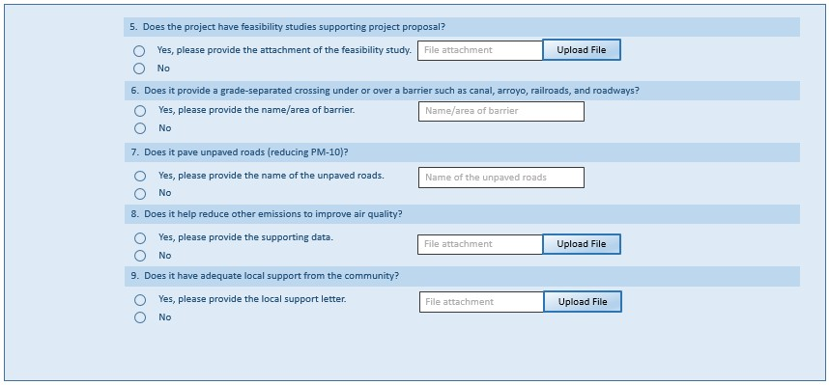

Figure 25: Submission Form 7

|  |  |  |  |
| --- | --- | --- | --- |
| Software Requirements Specification |  | Date  **2/18/2016 5:20 PM** | Page  **35** |

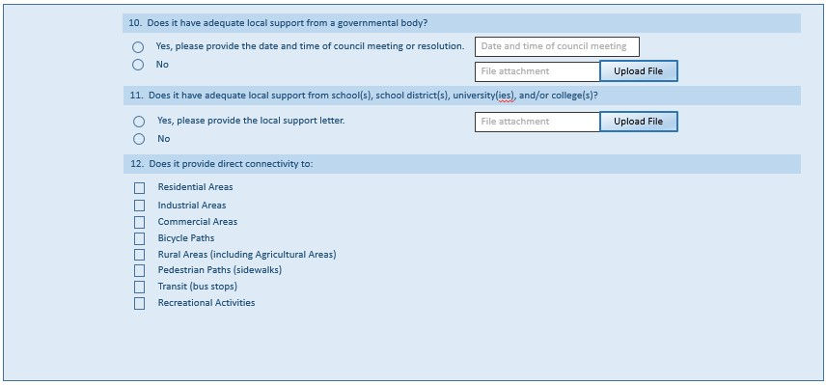

Figure 26: Submission Form 8

Figure 27: Submission Form 9

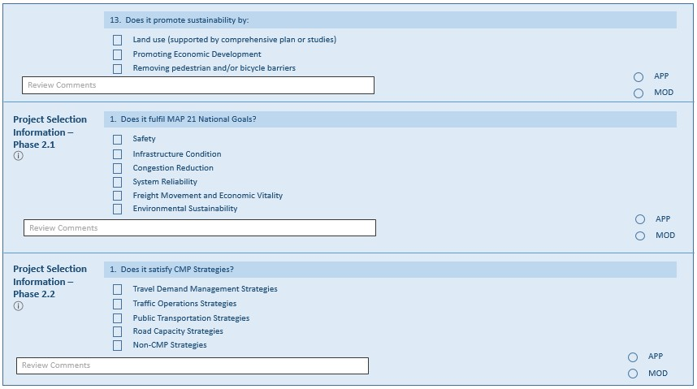

|  |  |  |  |
| --- | --- | --- | --- |
| Software Requirements Specification |  | Date  **2/18/2016 5:20 PM** | Page  **36** |

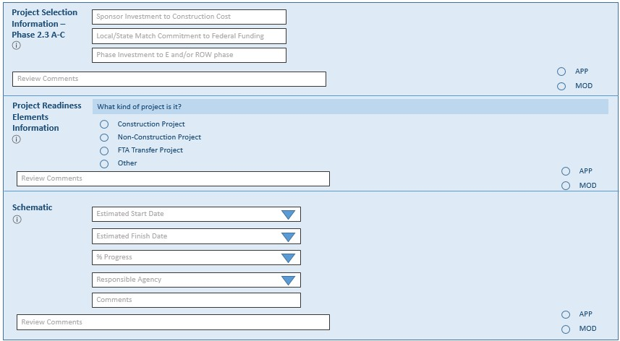

Figure 28: Submission Form 10

Figure 29: Submission Form 11

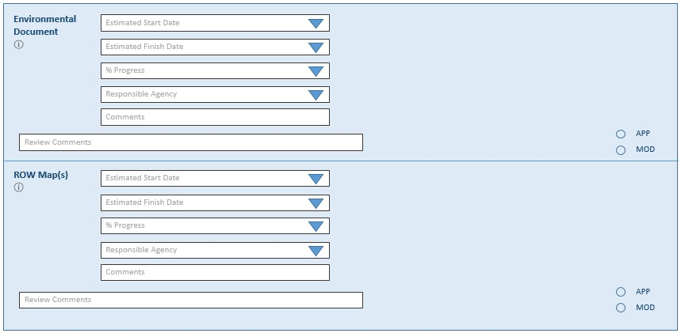

|  |  |  |  |
| --- | --- | --- | --- |
| Software Requirements Specification |  | Date  **2/18/2016 5:20 PM** | Page  **37** |

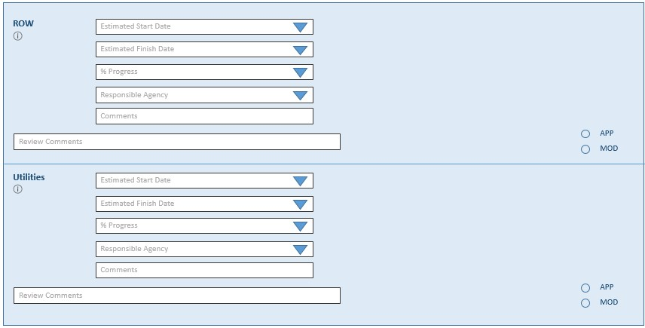

Figure 30: Submission Form 12

Figure 31: Submission Form 13

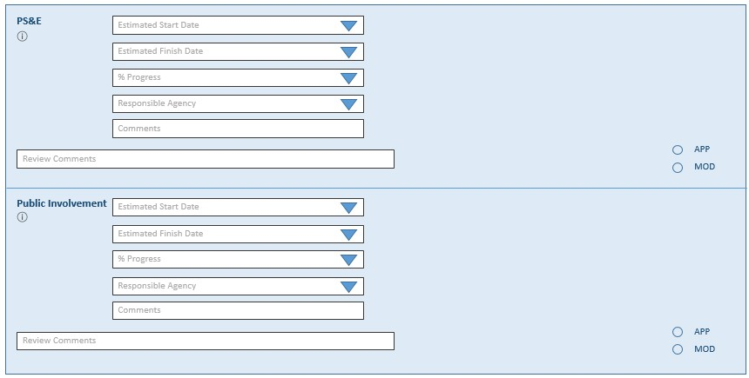

|  |  |  |  |
| --- | --- | --- | --- |
| Software Requirements Specification |  | Date  **2/18/2016 5:20 PM** | Page  **38** |

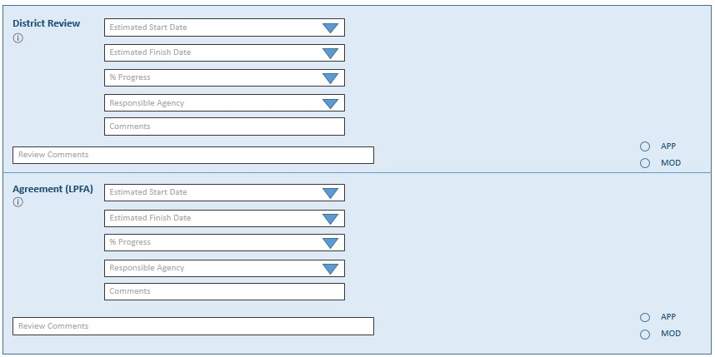

Figure 32: Submission Form 14

Figure 33: Submission Form 15

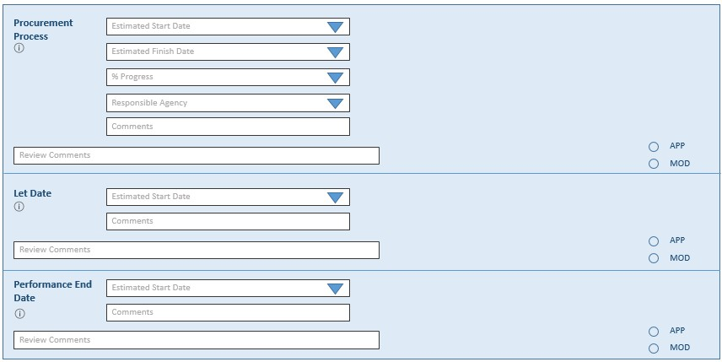

|  |  |  |  |
| --- | --- | --- | --- |
| Software Requirements Specification |  | Date  **2/18/2016 5:20 PM** | Page  **39** |

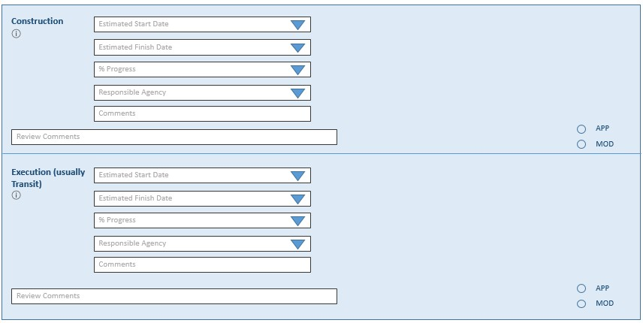

Figure 34: Submission Form 16

Figure 35: Submission Form 17

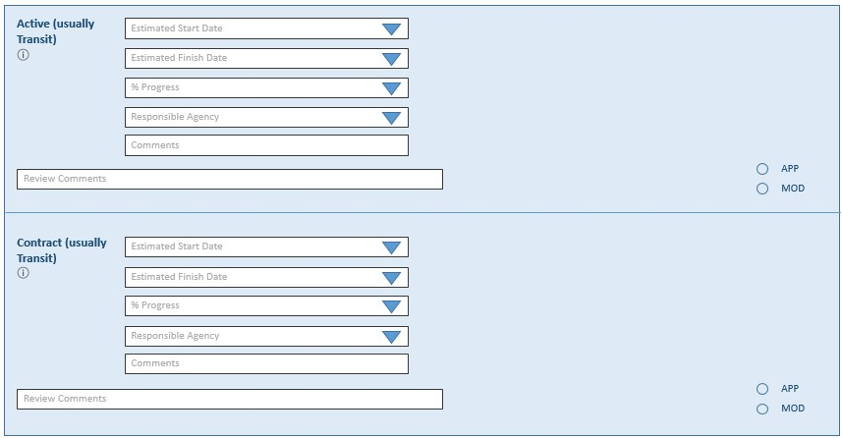

|  |  |  |  |
| --- | --- | --- | --- |
| Software Requirements Specification |  | Date  **2/18/2016 5:20 PM** | Page  **40** |

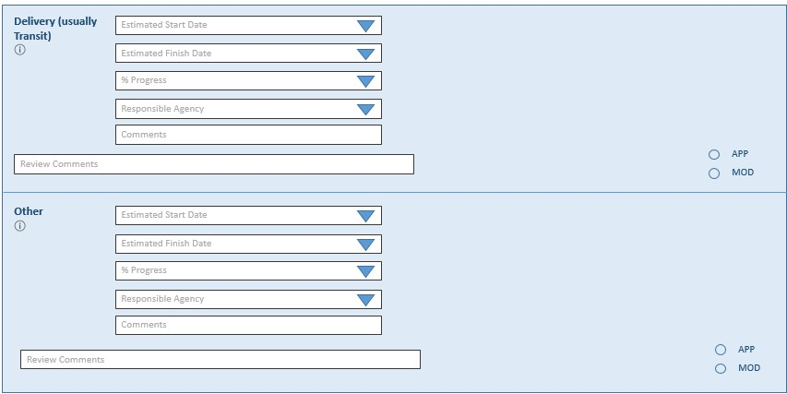

Figure 36: Submission Form 18

Figure 37: Submission Form 19

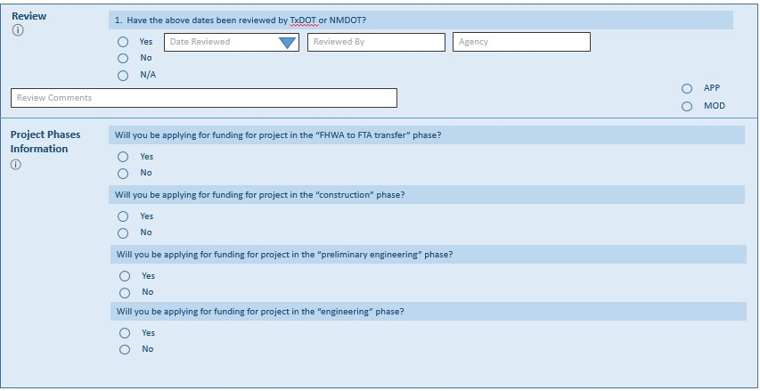

|  |  |  |  |
| --- | --- | --- | --- |
| Software Requirements Specification |  | Date  **2/18/2016 5:20 PM** | Page  **41** |

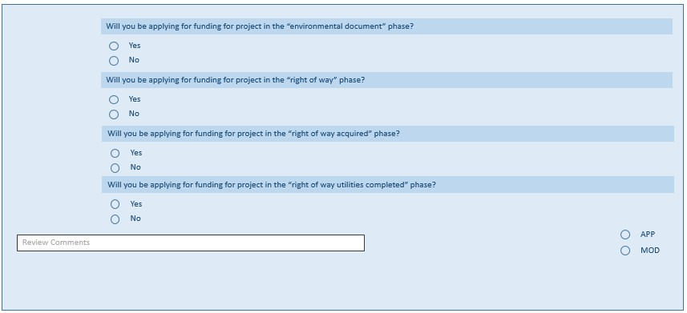

Figure 38: Submission Form 20

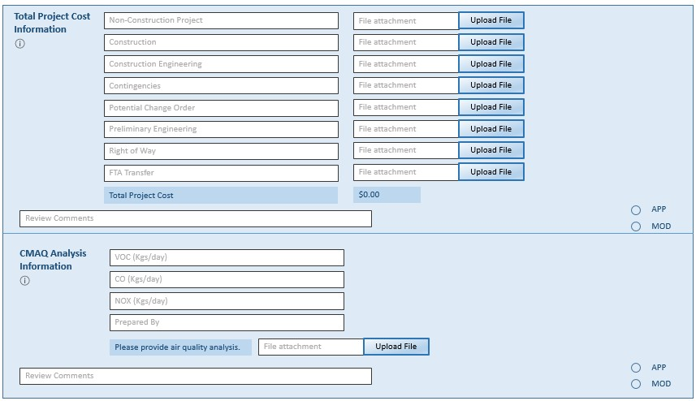

Figure 39: Submission Form 21

|  |  |  |  |
| --- | --- | --- | --- |
| Software Requirements Specification |  | Date  **2/18/2016 5:20 PM** | Page  **42** |

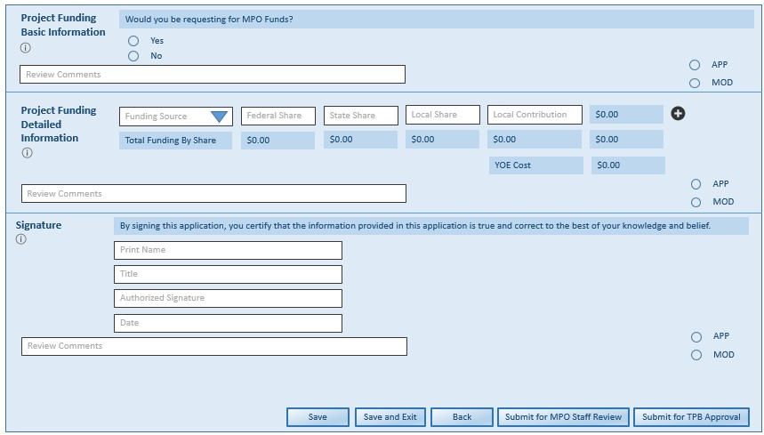

Figure 40: Submission Form 22

**3.1.1.5.3. Manage Funded Projects Page**

[SRS 52] The Management Progress Information Bar shall include the following elements as shown in Figure

41.

Figure 41: Management Progress Information Bar



[SRS 53] The Management page shall include the following as shown in Figure 42:

a. Post-login Heading b. Menu bar

c. Management progress information bar d. Management search menu

e. Management result area

|  |  |  |  |
| --- | --- | --- | --- |
| Software Requirements Specification |  | Date  **2/18/2016 5:20 PM** | Page  **43** |

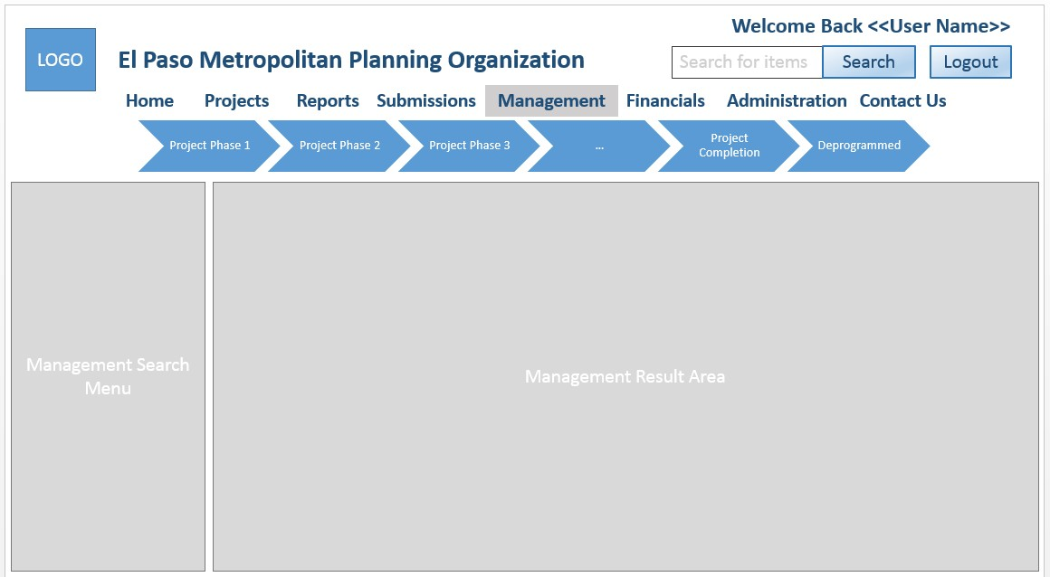

Figure 42: Management Page

[SRS 54] The management search menu shall contain an option for “Funded Projects”.

[SRS 55] The Funded Projects search menu shall include the following as shown in Figure 43:

a. Label that displays “Funded Projects” b. Text input box labeled as “MPO ID” c. Text input box labeled as “Keyword”. d. Button labeled as “Clear”

e. Button labeled as “Search”

f. Information icon about funded projects.

[SRS 56] The Awarded Projects Result Area shall display a table with the following elements as shown in

Figure 43:

a. Column labeled as “MPO ID”

b. Column labeled as “Fiscal Year”

c. Column labeled as “Project Type”

d. Column labeled as “Status”

e. Column labeled as “Action” with a button labeled as “Update” and a button labeled as “View”

f. Sort button for the “ID” column

g. Sort button for the “Fiscal Year” column h. Sort button for the “Project Type” column i. Sort button for the “Status” column

|  |  |  |  |
| --- | --- | --- | --- |
| Software Requirements Specification |  | Date  **2/18/2016 5:20 PM** | Page  **44** |

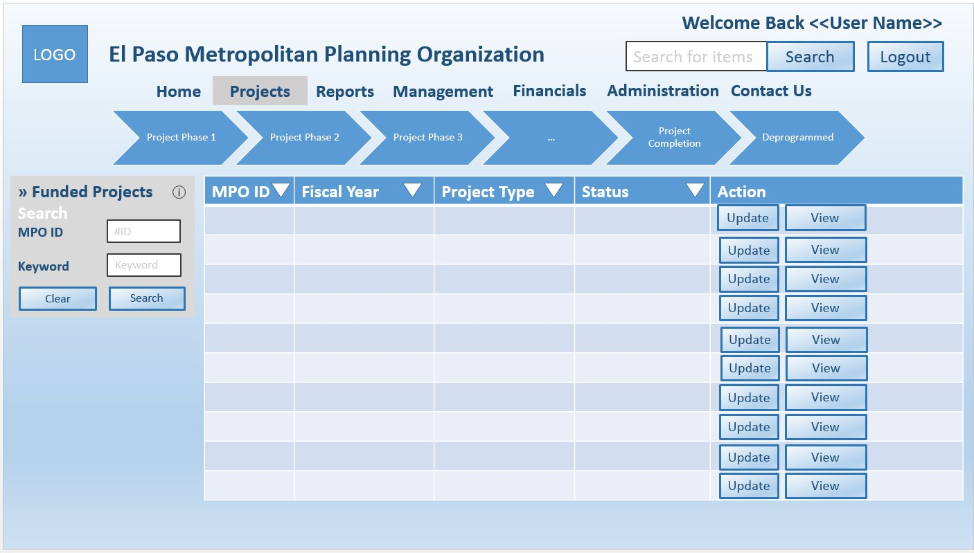

Figure 43: Manage Funded Projects Page

**3.1.1.6. Reports Page**

[SRS 57] The Reports page shall display the following elements as shown in Figure 44. a. The appropriate heading dependent on log-in status

b. Menu bar

c. Report mouseover menu d. Report search menu

e. Report result area f. File icon button.

Figure 44: Reports Page

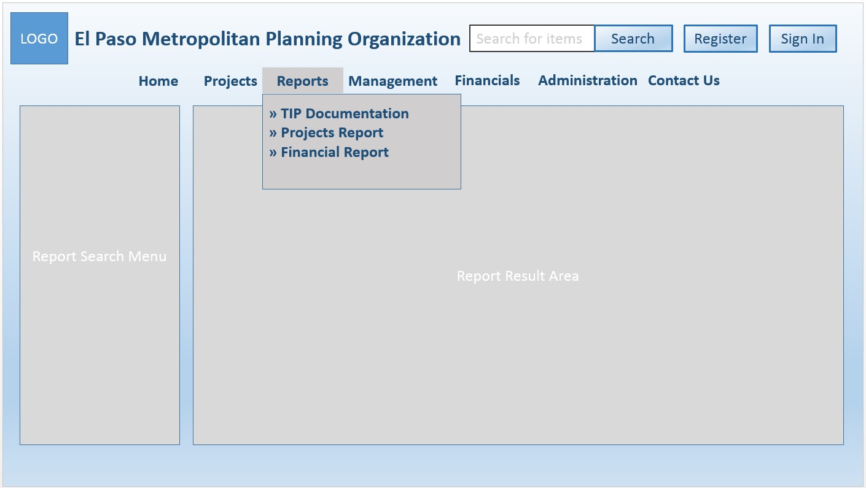

[SRS 58] The Report Mouseover Menu shall contain options to view the following reports:

a. TIP documentation

|  |  |  |  |
| --- | --- | --- | --- |
| Software Requirements Specification |  | Date  **2/18/2016 5:20 PM** | Page  **45** |

b. Projects report

c. Financial report.

**3.1.1.6.1. TIP Documentation Page**

[SRS 59] The TIP Documentation shall contain the following options for searching for TIP reports and amendments:

a. TIP Reports

b. TIP Amendments.

[SRS 60] The TIP Reports Search Menu shall display the following elements as shown in Figure 45:

a. Drop down list box labeled as “Fiscal Year”

b. Button labeled as “Clear”

c. Button labeled as “Search”.

d. Information icon about TIP Reports.

[SRS 61] The “TIP Reports” Report Result Area shall display a table with the following elements as shown in

Figure 45:

a. Column labeled as “Document”

b. Column labeled as “TPB Approval”

c. Column labeled as “STIP Approval”

d. Sort button for the “Document” column

e. Sort button for the “TPB Approval” column

f. Sort button for the “STIP Approval” column

g. Elements displayed in the “Document” column are hyperlinks to the approved TIP reports

h. Elements displayed in the “TPB Approval” column are hyperlinks to the meeting minutes

where the TIP reports are approved

i. Elements displayed in the “STIP Approval” column are hyperlinks to the approval letter from the State and Federal agencies.

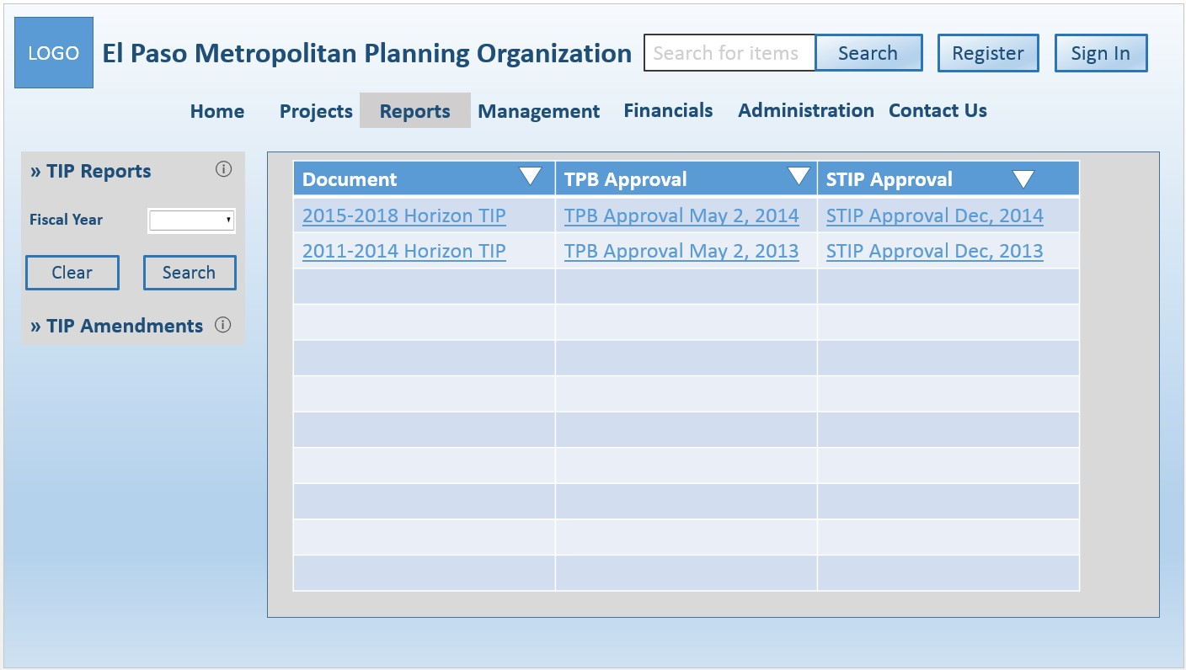

Figure 45: TIP Report Page

[SRS 62] The TIP Amendments Search Menu shall display the following elements as shown in Figure 46:

a. Drop down list box labeled as “Project Type”

b. Drop down list box labeled as “Amendment Type”

|  |  |  |  |
| --- | --- | --- | --- |
| Software Requirements Specification |  | Date  **2/18/2016 5:20 PM** | Page  **46** |

c. Drop down list box labeled as “Area”

d. Drop down list box labeled as “Fiscal Year”

e. Button labeled as “Clear”

f. Button labeled as “Search”

g. Information icon about TIP Amendment.

[SRS 63] The “TIP Amendments” Report Result Area shall display a table with the following elements as

shown in Figure 46:

a. Column labeled as “Document”

b. Column labeled as “TPB Approval”

c. Column labeled as “STIP Approval”

d. Sort button for the “Document” column

e. Sort button for the “TPB Approval” column

f. Sort button for the “STIP Approval” column

g. Elements displayed in the “Document” column are hyperlinks to amendments

h. Elements displayed in the “TPB Approval” column are hyperlinks to the meeting minutes

where the amendments are approved

i. Elements displayed in the “STIP Approval” column are hyperlinks to the approval letter from

the State and Federal agencies.

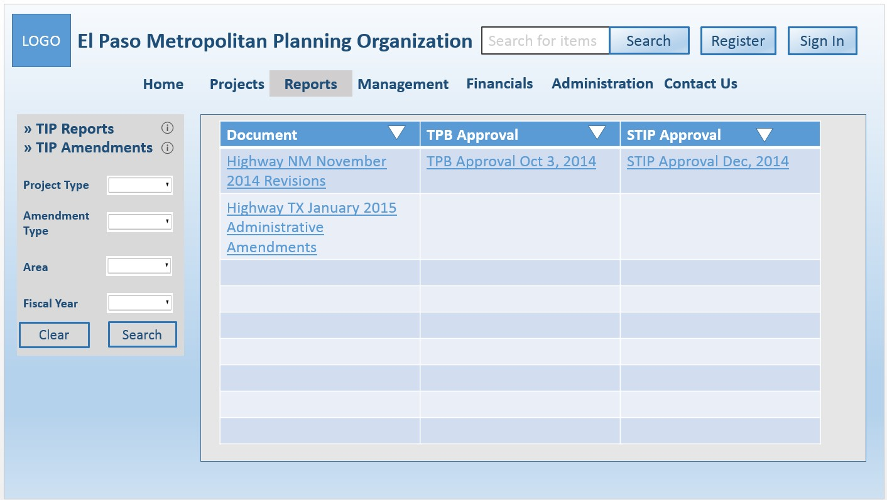

Figure 46: TIP Amendment Page

**3.1.1.6.2. Projects Report Page**

[SRS 64] The Projects Report shall display the following elements as shown in Figure 47:

a. Label that displays “By Project ID (1 ID per line)”

b. Text input box labeled as “ID”

c. Label that displays “By Filters”

d. Drop down list box labeled as “Funding Source”

e. Drop down list box labeled as “Federal/Functional Classification”

f. Drop down list box labeled as “Area”

g. Drop down list box labeled as “District”

h. Drop down list box labeled as “Status”

i. Drop down list box labeled as “Sponsor”

j. Drop down list box labeled as “Fiscal Year”

|  |  |  |  |
| --- | --- | --- | --- |
| Software Requirements Specification |  | Date  **2/18/2016 5:20 PM** | Page  **47** |

k. Text input box labeled as “Keyword” l. Label that displays “Content Filter” m. Check box labeled as “Project ID”

n. Check box labeled as “Project Title”

o. Check box labeled as “Project Description”

p. Check box labeled as “Termini”

q. Check box labeled as “Network”

r. Check box labeled as “Total Project Cost”

s. Check box labeled as “Sponsor”

t. Check box labeled as “YOE”

u. Check box labeled as “Project Readiness Information”

v. Check box labeled as “Project Completion Information”

w. Check box labeled as “Detailed Project Information”

x. Button labeled as “Clear”

y. Button labeled as “Generate Report”

z. Information icon about Projects Report.

Figure 47: Projects Report Page

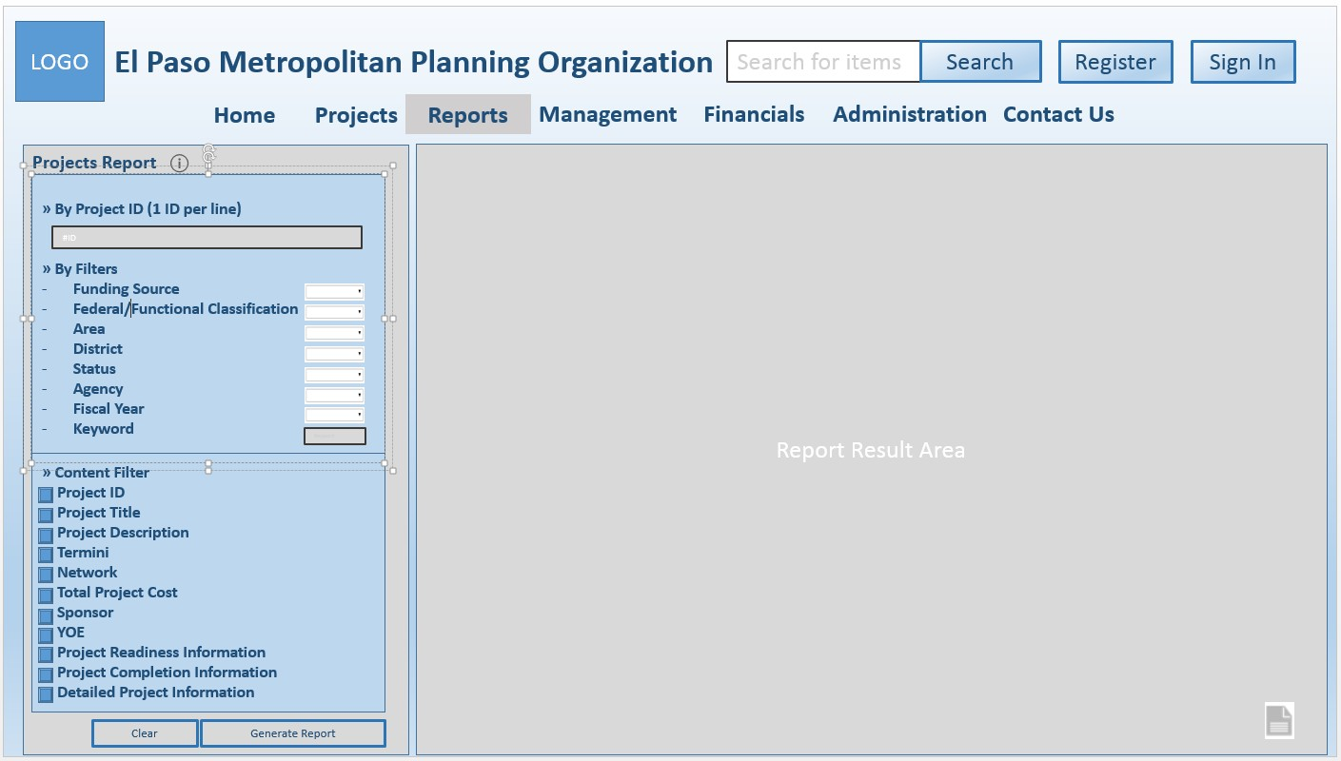

[SRS 65] The Report Result Area, as shown in Figure 47, shall display a pdf report containing filtered results as specified by the left panel and a file icon button.

**3.1.1.6.3. Financial Report Page**

[SRS 66] The Financial Report shall display the following elements as shown in Figure 48:

a. Label that displays “By Project ID (1 ID per line)”

b. Text input box labeled as “ID”

c. Label that displays “By Filters”

d. Drop down list box labeled as “Funding Source”

e. Drop down list box labeled as “Federal/Functional Classification”

f. Drop down list box labeled as “Area”

g. Drop down list box labeled as “District”

h. Drop down list box labeled as “Status”

i. Drop down list box labeled as “Sponsor”

j. Drop down list box labeled as “Fiscal Year”

k. Text input box labeled as “Keyword”

|  |  |  |  |
| --- | --- | --- | --- |
| Software Requirements Specification |  | Date  **2/18/2016 5:20 PM** | Page  **48** |

l. Label that displays “Content Filter”

m. Check box labeled as “Project ID”

n. Check box labeled as “Project Title”

o. Check box labeled as “Project Description”

p. Check box labeled as “Federal Share”

q. Check box labeled as “Regional Share”

r. Check box labeled as “Local Share”

s. Check box labeled as “Lcl/State Contribution”

t. Check box labeled as “Total Project Cost”

u. Drop down list box labeled as “Funding Source”

v. Button labeled as “Clear”

w. Button labeled as “Generate Report”

x. Information icon about Financial Report.

Figure 48: Financial Report

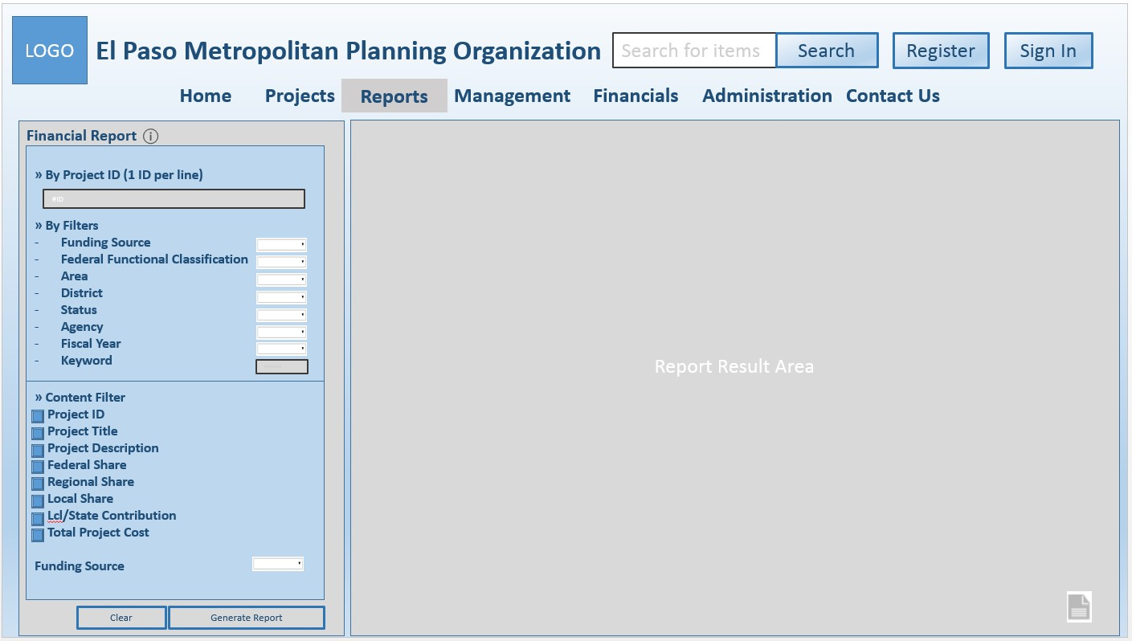

[SRS 67] The Report Result Area, as shown in Figure 48, shall display a pdf file containing filtered results as specified by the left panel and a file icon button.

**3.1.1.7. Register Page**

[SRS 68] The Register page shall display the following elements as shown in Figure 49. a. Label that displays “Register”.

b. Text input box labeled as “First Name”.

c. Text input box labeled as “Middle Initial Name”.

d. Text input box labeled as “Last Name”.

e. Text input box labeled as “Organization Name”. f. Text input box labeled as “Department Name”. g. Text input box labeled as “Position Title”.

h. Text input box labeled as “Department Contact Number”.

i. Text input box labeled as “Work Contact Number”.

j. Text input box labeled as “Email”.

k. Text input box labeled as “User Name”.

l. Text input box labeled as “Password”.

m. Text input box labeled as “Re-entered Password”.

|  |  |  |  |
| --- | --- | --- | --- |
| Software Requirements Specification |  | Date  **2/18/2016 5:20 PM** | Page  **49** |

n. Label that displays “By clicking Register, your account request will be sent to the

Administrator”.

o. Button labeled as “Register”.

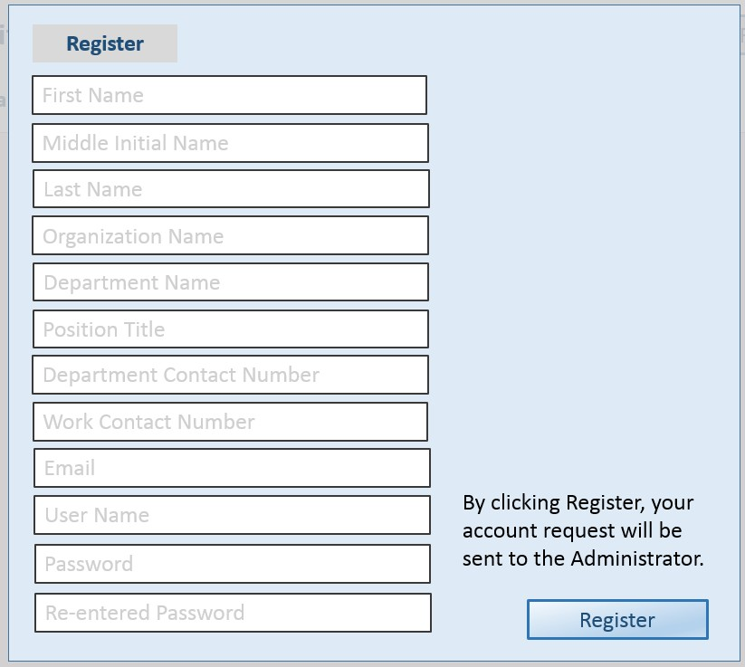

Figure 49: Register Page

[SRS 69] The acknowledgement for the Register page shall display the following text: “Thank you. Your account request has been submitted and is pending for approval by an Administrator. If you have any questions, please contact us at [support@elpasompo.org”.](mailto:support@elpasompo.org)

**3.1.1.8. Sign In Page**

[SRS 70] The Sign-In page shall display the following elements as shown in Figure 50. a. Label that displays “Sign in”.

b. Text input box labeled as “User Login”.

c. Text input box labeled as “Password”.

d. Button labeled as “Sign in”.

|  |  |  |  |
| --- | --- | --- | --- |
| Software Requirements Specification |  | Date  **2/18/2016 5:20 PM** | Page  **50** |

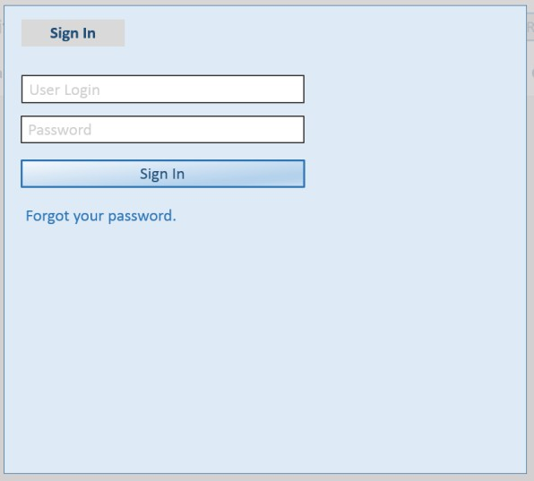

Figure 50: Sign In Page

**3.1.1.9. Management Page for MPO Staff**

[SRS 71] The Management Page for MPO Staff shall display the following elements as shown in . a. Post-login Heading

b. Menu bar

c. Management mouseover menu d. Management search menu

e. Management result area

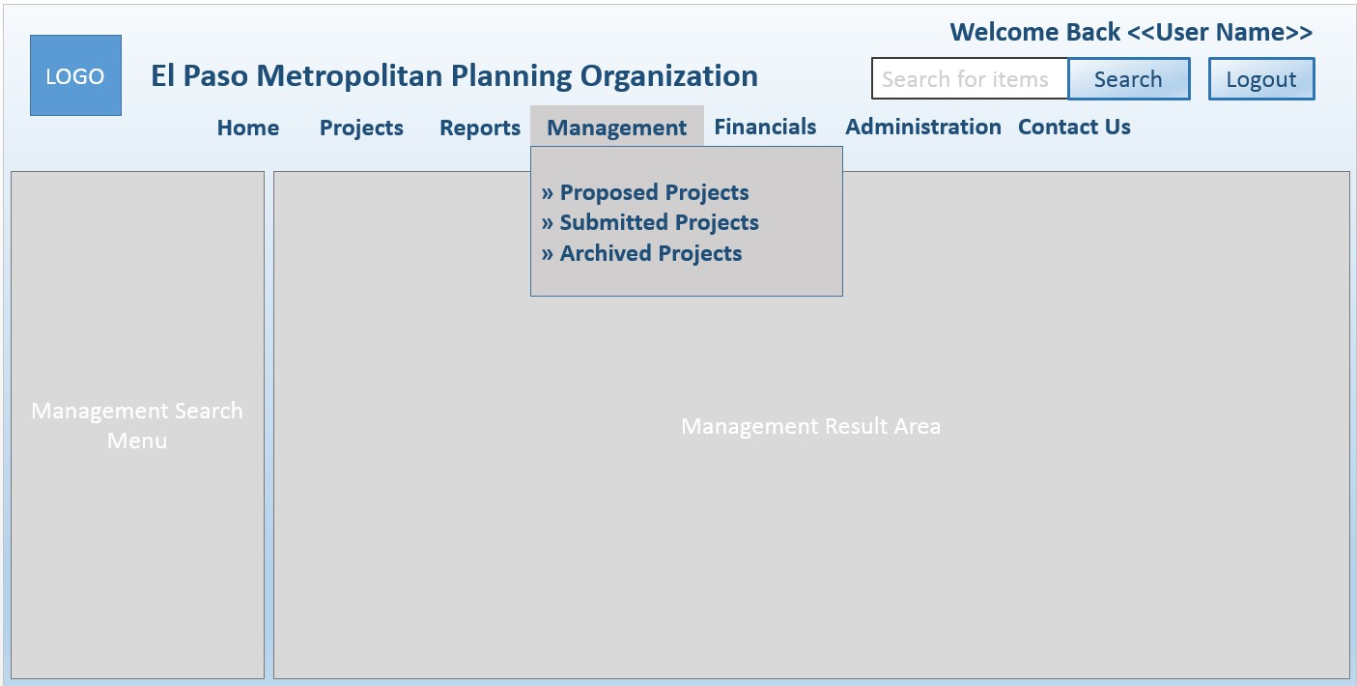

Figure 51: Management Page for MPO Staff

[SRS 72] The management mousemove menu for MPO staff shall contain the following options:

a. Proposed Projects b. Submitted Projects c. Archived Projects.

**3.1.1.9.1. Proposed Projects**

[SRS 73] The Proposed Projects search menu shall include the following as shown in Figure 52:

|  |  |  |  |
| --- | --- | --- | --- |
| Software Requirements Specification |  | Date  **2/18/2016 5:20 PM** | Page  **51** |

a. Label that displays “Search”

b. Text input box labeled as “MPO ID” c. Text input box labeled as “Keyword”. d. Button labeled as “Clear”

e. Button labeled as “Search”

f. Information icon about projects to be reviewed.

[SRS 74] The Proposed Projects Result Area shall display a table with the following elements as shown in

Figure 52:

a. Column labeled as “MPO ID”

b. Column labeled as “Fiscal Year”

c. Column labeled as “Project Type”

d. Column labeled as “Status”

e. Column labeled as “Action” with a button labeled as “Review”

f. Sort button for the “MPO ID” column

g. Sort button for the “Fiscal Year” column

h. Sort button for the “Project Type” column

i. Sort button for the “Status” column

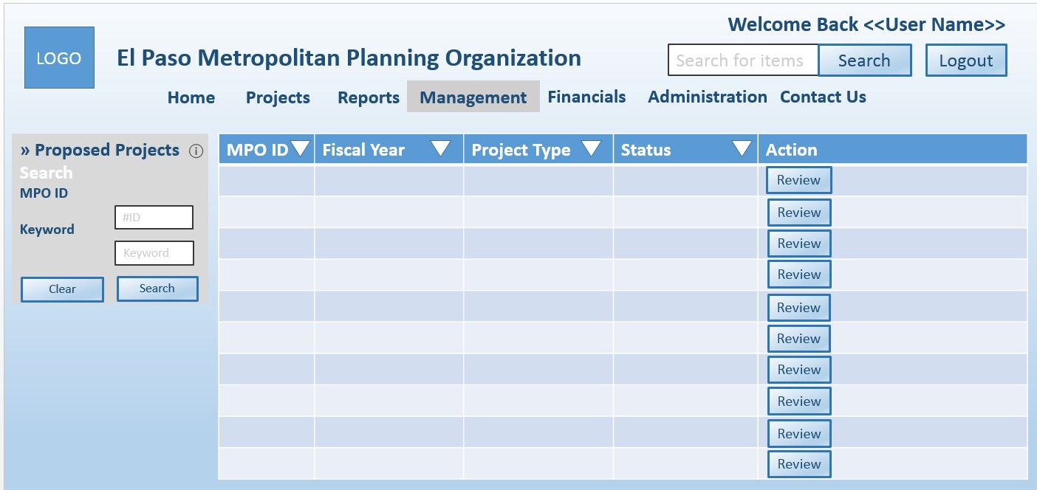

Figure 52: Proposed Projects Page for MPO Staff

[SRS 75] At the end of the proposed project review, the system shall display the following buttons as shown in a. Button labeled as “Save”

b. Button labeled as “Save and Exit”

c. Button labeled as “Submit”.

|  |  |  |  |
| --- | --- | --- | --- |
| Software Requirements Specification |  | Date  **2/18/2016 5:20 PM** | Page  **52** |

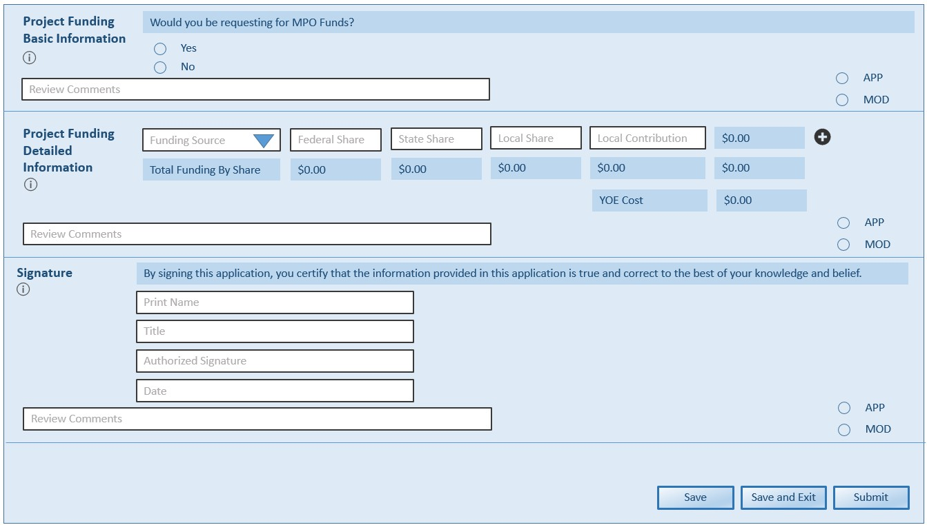

Figure 53: Proposed Project Review for MPO Staff

**3.1.1.9.2. Submitted Projects**

[SRS 76] The Submitted Projects search menu for MPO Staff shall include the following as shown in Figure 54:

a. Label that displays “Search”

b. Text input box labeled as “MPO ID” c. Text input box labeled as “Keyword” d. Button labeled as “Clear”

e. Button labeled as “Search”

f. Information icon about projects to be reviewed.

[SRS 77] The Submitted Projects result area shall display a table with the following elements as shown in

Figure 54:

a. Column labeled as “MPO ID”

b. Column labeled as “Fiscal Year”

c. Column labeled as “Project Type”

d. Column labeled as “Status”

e. Column labeled as “Action” with a button labeled as “Update”, a button labeled as “View”,

and “a button labeled as “Approval Letter”

f. Sort button for the “MPO ID” column

g. Sort button for the “Fiscal Year” column h. Sort button for the “Project Type” column i. Sort button for the “Status” column

[SRS 78] The Approval Letter pop-up window shall display the following elements as shown in a. Label that displays “TPB Approval Letter”

b. Text input button labeled as “File Attachment”

c. Button labeled as “Upload File”

d. Label that displays “State Approval Letter”

e. Text input button labeled as “File Attachment”

f. Button labeled as “Upload File”

g. Label that displays “Federal Approval Letter”

h. Text input button labeled as “File Attachment”

|  |  |  |  |
| --- | --- | --- | --- |
| Software Requirements Specification |  | Date  **2/18/2016 5:20 PM** | Page  **53** |

i. Button labeled as “Upload File”

j. Close button.

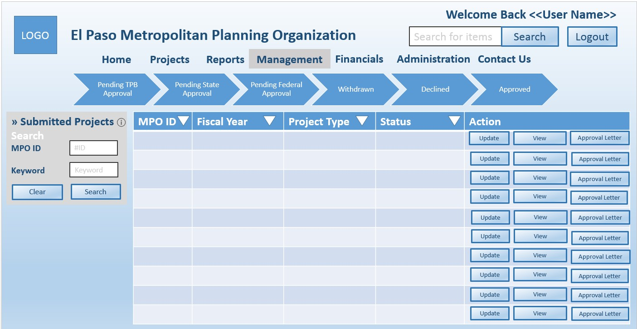

Figure 54: Submitted Project Page for MPO Staff

[SRS 79] The Archived Projects search menu shall include the following as shown in Figure 55:

a. Text input box labeled as “MPO ID” b. Text input box labeled as “Keyword”. c. Button labeled as “Clear”

d. Button labeled as “Search”

e. Information icon about archived projects.

[SRS 80] The Archived Projects Result Area shall display a table with the following elements as shown in

Figure 55:

a. Column labeled as “ID”

b. Column labeled as “Fiscal Year”

c. Column labeled as “Project Type”

d. Column labeled as “Status”

e. Column labeled as “Action” with a button labeled as “View”

f. Sort button for the “ID” column

g. Sort button for the “Fiscal Year” column h. Sort button for the “Project Type” column i. Sort button for the “Status” column

|  |  |  |  |
| --- | --- | --- | --- |
| Software Requirements Specification |  | Date  **2/18/2016 5:20 PM** | Page  **54** |

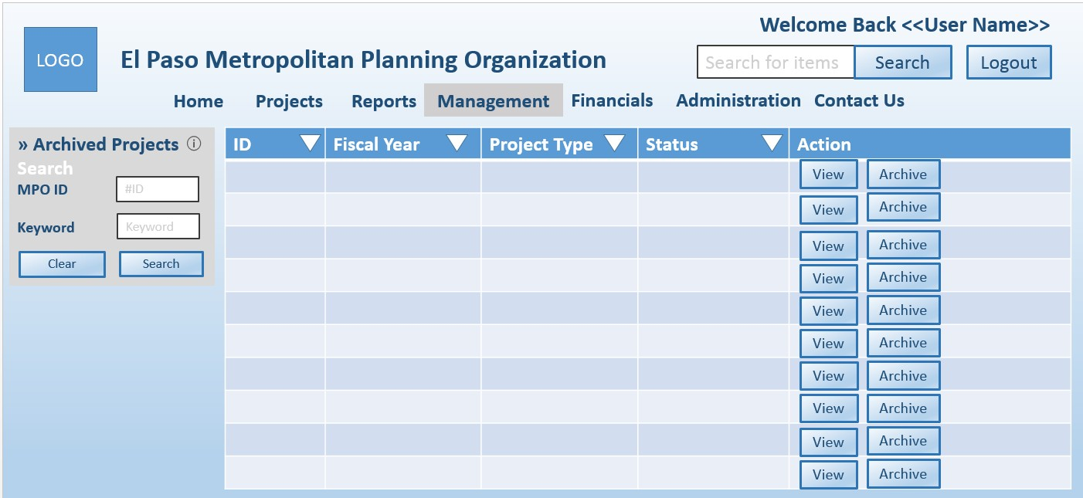

Figure 55: Archived Projects for MPO Staff

**3.1.1.10. Contact Us Page**

[SRS 81] The Contact Us page shall display the following elements as shown in Figure 56:

a. Text input box labeled as “Name”

b. Text input box labeled as “Email”

c. Text input box labeled as “Phone No.” d. Text input box labeled as “Messages” e. Button labeled as “Cancel”

f. Button labeled as “Send”

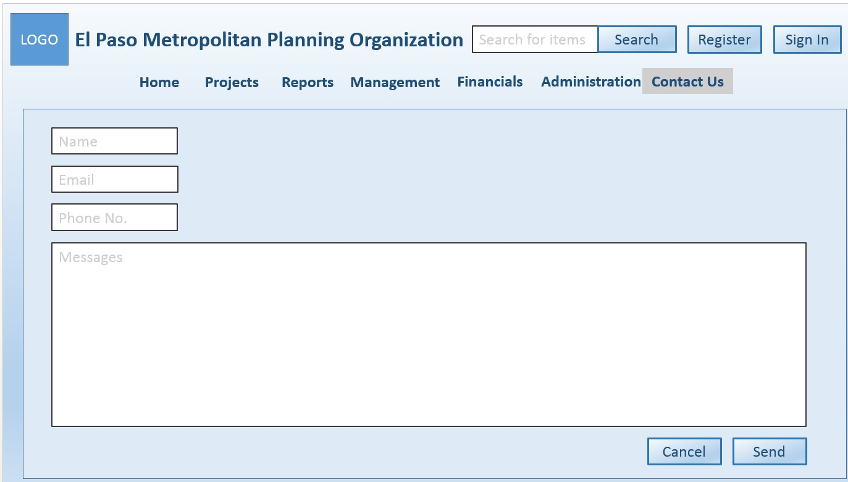

Figure 56: Contact Us Page

**3.1.1.11. Administration Page**

[SRS 82] The Administration page shall display the elements as shown in Figure 57:

|  |  |  |  |
| --- | --- | --- | --- |
| Software Requirements Specification |  | Date  **2/18/2016 5:20 PM** | Page  **55** |

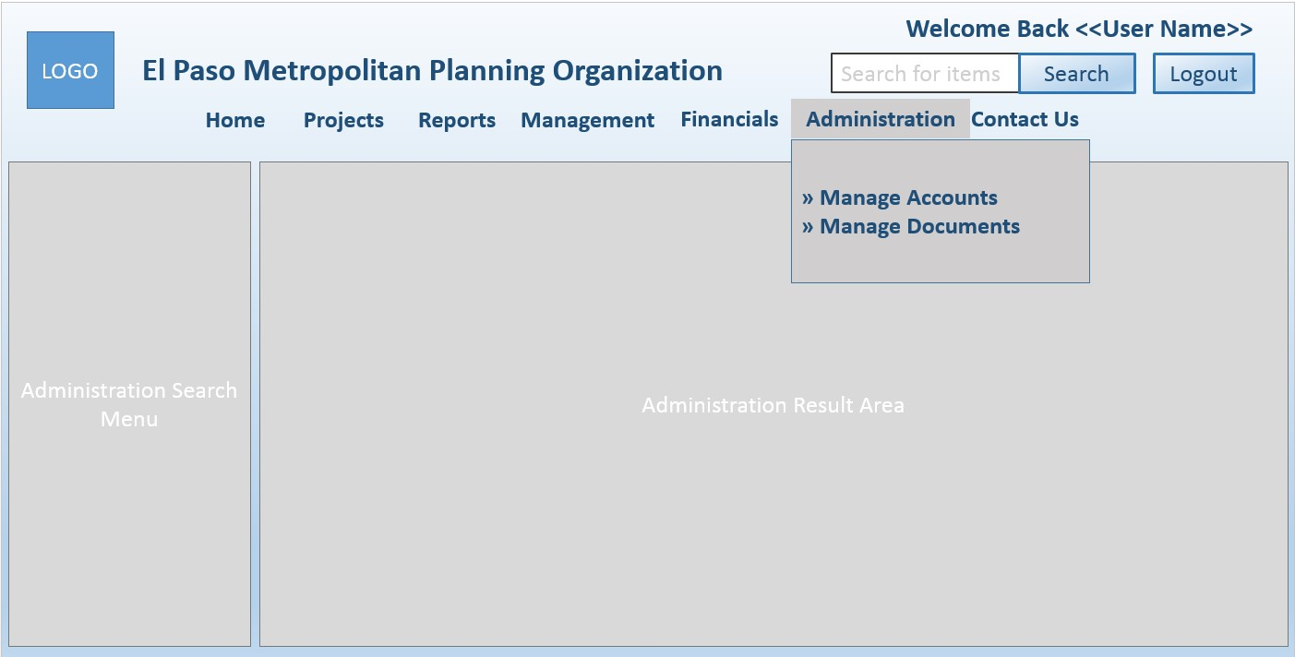

Figure 57: Administration Page

[SRS 83] The Administration page for Accounts shall display the elements as shown in Figure 58. [SRS 84] The Administration page for TIP Reports shall display the elements as shown in Figure 59. [SRS 85] The Add popup window shall display the elements as shown in Figure 60.

[SRS 86] The Administration page for TIP Amendments shall display the elements as shown in Figure 61.

Figure 58: Accounts Administration Page

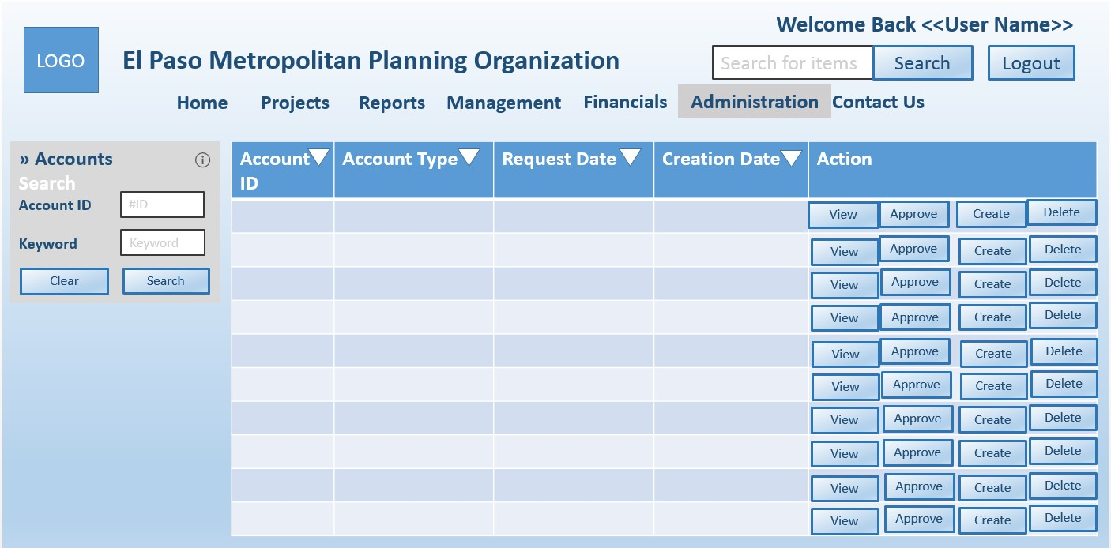

|  |  |  |  |
| --- | --- | --- | --- |
| Software Requirements Specification |  | Date  **2/18/2016 5:20 PM** | Page  **56** |

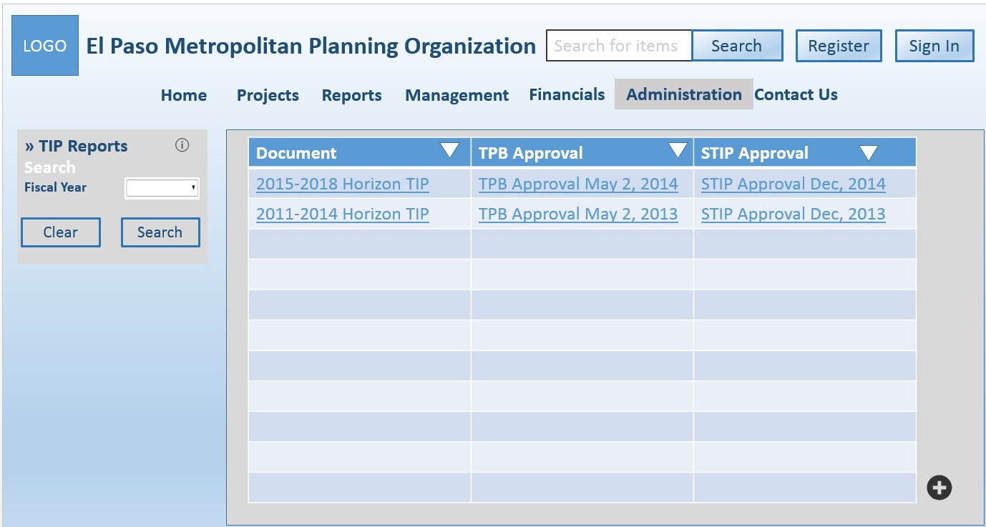

Figure 59: TIP Reports Administration Page

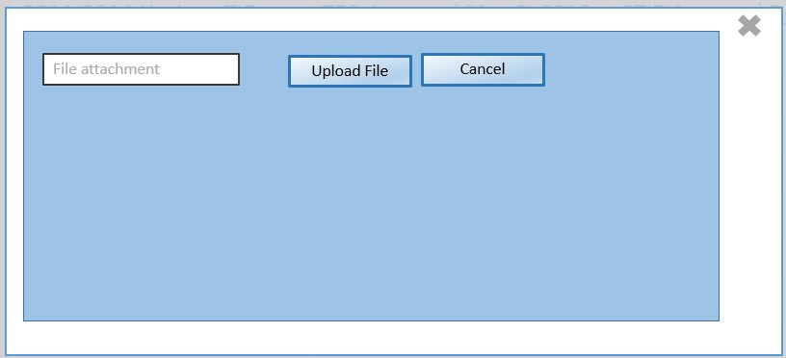

Figure 60: Add Pop-up

|  |  |  |  |
| --- | --- | --- | --- |
| Software Requirements Specification |  | Date  **2/18/2016 5:20 PM** | Page  **57** |

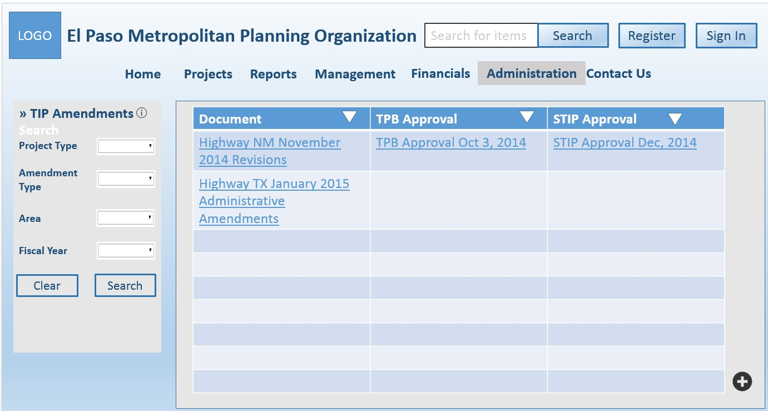

Figure 61: TIP Amendments Administration Page

**3.1.1.12. Financials Pages**

[SRS 87] The Financial Administration page shall contain the following elements as shown in Figure 62:

a. The appropriate heading dependent on log-in status b. Menu bar

c. Manage Funding sidebar d. Manage Category table

e. Manage Category Funding table.

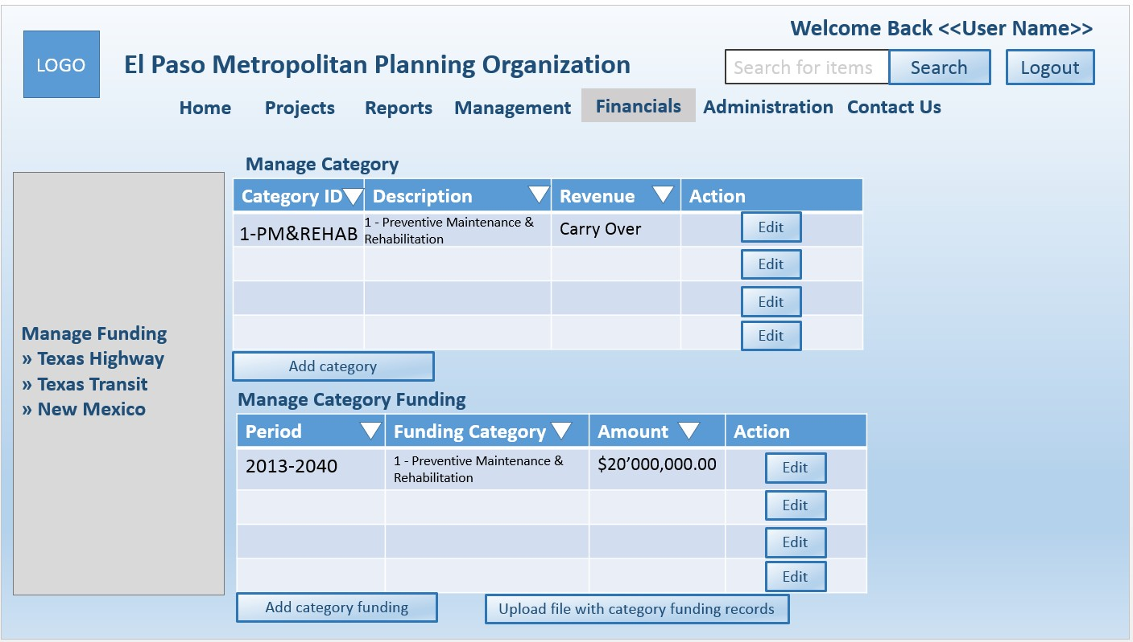

Figure 62: Financial Administration Page

|  |  |  |  |
| --- | --- | --- | --- |
| Software Requirements Specification |  | Date  **2/18/2016 5:20 PM** | Page  **58** |

[SRS 88] The Manage Funding sidebar shall contain the following elements as shown in Figure 62:

a. Texas Highway b. Texas Transit

c. New Mexico

[SRS 89] The Manage Category table shall contain the following elements as shown in Figure 62:

a. Category ID b. Description c. Revenue

d. Action

e. Edit button for each category f. Sort button for Category ID

g. Sort button for Description h. Sort button for Revenue

i. Button labeled as “Add category”.

[SRS 90] The Manage Category Funding table shall contain the following elements as shown in Figure 62:

a. Period

b. Funding Category c. Amount

d. Action

e. Edit button for each category f. Sort button for Period

g. Sort button for Funding Category h. Sort button for Amount

i. Button labeled as “Add category funding”

j. Button labeled as “Upload file with category funding records”.

[SRS 91] The Add category button shall display a form that will contain the following elements as shown in

Figure 63:

a. Input field labeled as “Category ID“

b. Input field labeled as “Revenue by Categories“

c. Checkbox fields labeled as “Revenue” with the following values:

i. Carry Over

ii. Non Carry Over

d. Input field labeled as “Growth Rate % “ e. Input field labeled as “Inflation Rate %“ f. Input field labeled as “Total Rate %“

g. Text area input field labeled as “Justification Note“

h. Button labeled as “Upload File button“

i. Button labeled as “Add new“

|  |  |  |  |
| --- | --- | --- | --- |
| Software Requirements Specification |  | Date  **2/18/2016 5:20 PM** | Page  **59** |

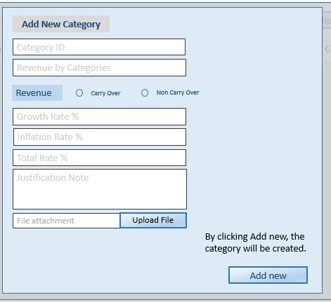

Figure 63: Add New Category Form

[SRS 92] The Edit category button shall display a form that will contain the following elements as shown in

Figure 64:

a. Drop down list box labeled as “Revenue by Categories”

b. Input field labeled as “Category ID“

c. Input field labeled as “Revenue by Categories“

d. Checkbox fields labeled as “Revenue” with the following values:

i. Carry Over

ii. Non Carry Over

e. Input field labeled as “Growth Rate % “ f. Input field labeled as “Inflation Rate %“ g. Input field labeled as “Total Rate %“

h. Text area input field labeled as “Justification Note“

i. Button labeled as “Upload File button“

j. Button labeled as “Clear “ k. Button labeled as “Delete “ l. Button labeled as “Save“

|  |  |  |  |
| --- | --- | --- | --- |
| Software Requirements Specification |  | Date  **2/18/2016 5:20 PM** | Page  **60** |

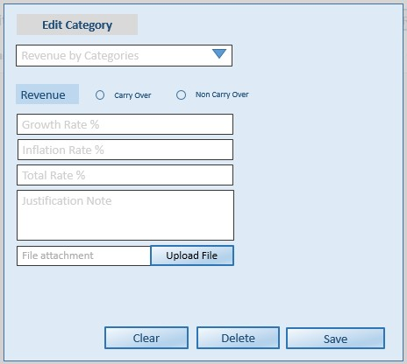

Figure 64: Edit Category Form

|  |  |  |  |
| --- | --- | --- | --- |
| Software Requirements Specification |  | Date  **2/18/2016 5:20 PM** | Page  **61** |

[SRS 93] The Add category funding button shall display a form that will contain the following elements as shown in Figure 7:

a. Input field labeled as “Period“

b. Drop down list box labeled as “Funding Category”

c. Checkbox fields labeled as “Revenue” with the following values:

i. Carry Over

ii. Non Carry Over

d. Input field labeled as “Amount $ “

e. Text area input field labeled as “Justification Note“

f. Button labeled as “Upload File button“

g. Button labeled as “Add new“

Figure 7: Add New Category Funding form

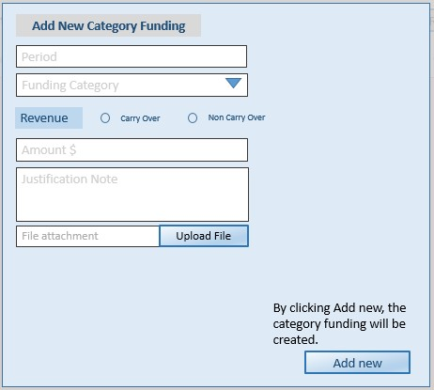

|  |  |  |  |
| --- | --- | --- | --- |
| Software Requirements Specification |  | Date  **2/18/2016 5:20 PM** | Page  **62** |

[SRS 94] The Edit category funding button shall display a form that will contain the following elements as shown in Figure 8:

a. Drop down list box labeled as “Period”

b. Checkbox fields labeled as “Revenue” with the following values:

i. Carry Over

ii. Non Carry Over

c. Drop down list box labeled as “Category ID”

d. Drop down list box labeled as “Category by Description”

e. Text area input field labeled as “Justification Note“

f. Button labeled as “Upload File button“

g. Button labeled as “Clear “ h. Button labeled as “Delete “ i. Button labeled as “Save“

Figure 8: Edit Category Funding form

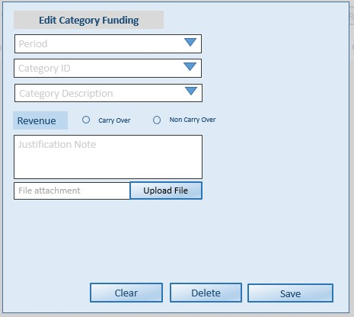

**3.1.2. Hardware Interfaces**

There are no hardware interface requirements specified at this time.

**3.1.3. Software Interfaces**

This section describes the characteristics of each interface between the other application systems and the system.

[SRS 95] The system shall use Google Maps JavaScript API to create web-based maps to identify the general location of the projects.

[SRS 96] The system shall use Google Maps Geocoding API web service to convert between addresses and geographic coordinates.

**3.1.4. Communications Interfaces**

There are no communications interfaces at this time.

|  |  |  |  |
| --- | --- | --- | --- |
| Software Requirements Specification |  | Date  **2/18/2016 5:20 PM** | Page  **63** |

**3.2. Behavioral Requirements**

This section describes the behavioral requirements of the system.

**3.2.1. Same Class of User**

This section describes requirements associated with a particular class of user. For complete requirements associated with the functionality given in Table 8, please refer to Section 3.2.3.

[SRS 97] The system shall have the following classes of users:

a. Regular User b. Project Lead c. MPO Staff

d. Administrator

e. MPO Lead user.

[SRS 98] Users shall not be subject to authentication by the system to access privileges at the “Regular User”

access level.

[SRS 99] The system shall provide authentication mechanisms to allow users to log in to access privileges at the following access levels:

a. Project Lead access level b. MPO Staff access level

c. Administrator access level

d. MPO Lead user access level.

Table 8: Privileges by Access Level

|  |  |  |  |  |  |
| --- | --- | --- | --- | --- | --- |
| Privileges\Classes  of User | Regular  User | Project  Lead | MPO  Staff | Administrator | MPO Lead  user |
| Create  Submission |  | X |  |  | X |
| Edit Submission |  | X |  |  | X |
| Delete  Submission |  | X |  |  | X |
| Approve  Submission |  |  | X |  | X |
| Approve User  Account Request |  |  |  |  | X |
| Create User  Account |  |  |  | X | X |
| Edit User  Account |  |  |  | X | X |
| Delete User  Account |  |  |  | X | X |
| Review  Submission |  |  | X |  | X |
| Review Model |  |  | X |  | X |
| Manage Funding |  |  | X |  | X |
| Archive |  |  | X |  | X |
| Manage Projects |  | X | X |  | X |
| Generate Report | X | X | X | X | X |
| View Project | X | X | X | X | X |
| View Report | X | X | X | X | X |

|  |  |  |  |
| --- | --- | --- | --- |
| Software Requirements Specification |  | Date  **2/18/2016 5:20 PM** | Page  **64** |

**3.2.2. Related Real-World Objects**

This section describes related real-world object requirements of the system. Please refer to the Class Diagram in

Appendix B.

**3.2.2.1. Project**

There are common elements around a proposed project and a funded project. This section described the common elements. Note that the Access and Excel data bases may use codes to denote the values associated with a field; as a result, the data type is denoted as TBD.

[SRS 100] The system shall store the fields presented in Table 10 for all archived, proposed and funded projects.

Table 9: Common elements associated with a project

|  |  |  |  |
| --- | --- | --- | --- |
| **Field** | **Data**  **Type** | **Values and Constraints** | **Comments** |
| Air Quality  Analysis-CO | Real | Required if the proposed  project is applying for  CMAQ funds. | Kgs/day |
| Air Quality  Analysis-NOX | Real | Required if the proposed  project is applying for  CMAQ funds. | Kgs/day |
| Air Quality  Analysis-VOC | Real | Required if the proposed  project is applying for  CMAQ funds. | Kgs/day |
| Area | TBD | See Appendix A for values |  |
| Capacity Project | Boolean | Values:  - True: Capacity project  - False: Not a capacity project | This field indicates whether the  project is a capacity project. |
| City | TBD | See Appendix A for values |  |
| County | TBD | Values:  - El Paso  - Dona Ana |  |
| DOT District | TBD | Values:  - Texas District 24  - NM District 1  - NM District 2 |  |
| Federal Fiscal Year | Date | Required |  |
| Federal Functional  Classification | TBD | See Appendix A for values |  |
| Fund Project Type | TBD | Values:  - Highway/Roadway  - Transit | MPO Staff is responsible for this  field. |
| Highway/roadway  Name | String |  | Related to Fund Project Type |
| Limit From | See  comments | Required only if the Fund  Project Type is highway/roadway. | Start point to denote the portion  of a highway that will undergo construction;  Type is given as latitude and longitude the format of:  degree minutes seconds N or S  degree minutes seconds E or W |

|  |  |  |  |
| --- | --- | --- | --- |
| Software Requirements Specification |  | Date  **2/18/2016 5:20 PM** | Page  **65** |

|  |  |  |  |
| --- | --- | --- | --- |
| Limit To | See  comments | Required only if the Fund  Project Type is highway/roadway. | End point to denote the portion of  a highway that will undergo construction  Type is given as latitude and longitude the format of:  degree minutes seconds N or S  degree minutes seconds E or W |
| Network Year | Date | Required |  |
| Number of  Existing Lanes | Integer | Required | Related to Capacity Project |
| Number of Miles | Real | Required | Related to Capacity Project |
| Number of  Projected Lanes | Integer | Required | Related to Capacity Project |
| Project Description | String | Required. 1 to 255  characters. | Description of the work to be  completed on the project |
| Project ID | String | Required | Temporary ID or MPO ID  depending on the workflow status |
| Project Name | String | Required. 1 to 255  characters. | Name of the project |
| Project Phases | TBD | See Appendix A for values |  |
| Project Type | TBD | See Appendix A for values |  |
| Remarks | String | Optional |  |
| Scope of Work | String | Required |  |
| Sponsor Agency | String |  |  |
| State System Road | TBD | Values:  - ON_State System Road  - OFF State System Road  - ON_OFF State System  Road |  |
| Transit  Information | TBD | See Appendix A for values |  |

[SRS 101] The MPO ID shall be a unique identifier.

**3.2.2.2. Proposed Project**

[SRS 102] The system shall store the fields presented in Table 10 for each proposed project.

Table 10: Project Table

|  |  |  |  |
| --- | --- | --- | --- |
| **Field** | **Data**  **Type** | **Values and Constraints** | **Comments** |
| Approved project  ID | String | Required if “Revision to  approved project” is  selected | MPO ID, CSJ, or CN |
| Project Readiness  Elements | TBD | Required if the project is  a construction project,  non-construction, or FTA  transfer project.  See Appendix A for values and subfields. |  |

|  |  |  |  |
| --- | --- | --- | --- |
| Software Requirements Specification |  | Date  **2/18/2016 5:20 PM** | Page  **66** |

|  |  |  |  |
| --- | --- | --- | --- |
| Project Selection  Information | TBD | See Appendix A for  questions, expected answer types, supporting evidences, and supporting evidence data types for project selection. |  |
| Submission  Deadline | Date |  | Entered by MPO Staff |
| Submission type | String | Values:  - New submission  - Revision to approved  project | Type of submission  Required field |
| Workflow Status | String | Values:  - Under Preparation  - Under Review  - Ready for Submission  - Modification Required  - Submitted to TPB | The workflow status of the  submission  “Under Review” indicates that the submission is being reviewed by the MPO staff |

[SRS 103] The system shall maintain the fields provided in Table 11 for each proposed transit project.

Table 11: Fields associated with Transit projects

|  |  |  |
| --- | --- | --- |
| **Field** | **Data**  **Type** | **Values and**  **Constraints** |
| Apportionment Year | Date |  |
| Section 5309ID | String |  |
| TDC Amount Requested | Real |  |
| Transit Project Type | TBD | Values:  Capital Operating Planning Administration |

[SRS 104] All proposed capacity projects shall have values entered into all of the following fields:

a. Number of Existing Lanes b. Number of Projected Lanes c. Number of Miles

d. Highway/roadway Name.

[SRS 105] The following fields shall contain values only when the proposed project is a capacity project:

a. Number of Existing Lanes b. Number of Projected Lanes c. Number of Miles

d. Highway/roadway Name.

[SRS 106] The Highway/Roadway Name field shall be completed for all proposed projects for which Fund

Project Type is Highway/Roadway type.

[SRS 107] The State System Road field shall be completed for all proposed projects for which Fund Project

Type is Highway/Roadway type.

[SRS 108] The Transit Information fields shall be completed for all proposed projects for which Fund Project

Type is Transit type.

|  |  |  |  |
| --- | --- | --- | --- |
| Software Requirements Specification |  | Date  **2/18/2016 5:20 PM** | Page  **67** |

[SRS 109] All proposed projects funded by CMAQ funds shall have the fields completed:

a. Air Quality Analysis VOC

b. Air Quality Analysis CO

c. Air Quality Analysis NOX.

[SRS 110] Only Highway/roadway fund projects shall be eligible for FHWA funds. [SRS 111] Only Transit fund projects shall be eligible for FTA fund.

[SRS 112] Project Lead shall be responsible for the fields described in Table 9.

[SRS 113] MPO Staff shall be responsible for the following fields as described in Table 12

Table 12: Fields for MPO Staff

|  |  |  |
| --- | --- | --- |
| **Field** | **Data Type** | **Comments** |
| CN | String | NMDOT project identification number. |
| CSJ | String | TxDOT project identification number. |
| Fund Project Type | Boolean |  |
| MPO ID# | TBD | MPO project identification number. |

**3.2.2.3. Submitted Projects**

[SRS 114] The system shall store the fields presented in Table 10 for each submitted project.

Table 13: Submitted Project Table

|  |  |  |  |
| --- | --- | --- | --- |
| **Field** | **Data**  **Type** | **Values and Constraints** | **Comments** |
| TPB approval | Link |  | Link to the TPB approval letter |
| Federal approval | Link | optional | Link to the federal approval letter |
| State approval | Link |  | Link to the state approval letter |
| Submission status | String | Values:  - Pending TPB approval  - Pending state approval  - Pending federal approval  - Withdrawn  - Declined  Approved | Note that status “Pending state  approval” infers that it has been  approved by the TPB.  The status “Approved” indicates that the submission has been approved to proceed and is dependent on the nature of the project |

**3.2.2.4. Funded Projects**

[SRS 115] The system shall store the fields presented in Table 14 for each funded project.

Table 14: Funded Project Fields

|  |  |  |
| --- | --- | --- |
| **Field** | **Data Type** | **Values and Constraints** |
| Amendment  date | Date | Required if “Revision to approved project” is selected |
| CN# | String | Required if the project is a transit project and has been  approved by TPB |
| CSJ# | String | Required if the project is a highway/roadway project and  has been approved by TPB |
| TIP Name | String |  |
| TIP Year | Date |  |

|  |  |  |  |
| --- | --- | --- | --- |
| Software Requirements Specification |  | Date  **2/18/2016 5:20 PM** | Page  **68** |

[SRS 116] The CSJ# field shall be completed for funded project for which Fund Project Type is

Highway/Roadway type.

[SRS 117] The CN# field shall be completed for funded project for which Fund Project Type is Transit type. [SRS 118] The project readiness elements shall be completed for projects that are:

a. Construction

b. Non-Construction c. FTA Transfer.

[SRS 119] The system shall maintain the fields provided in Table 11 for each funded transit project.

Table 15: Fields associated with Transit projects

|  |  |
| --- | --- |
| **Field** | **Data Type** |
| TDC Award Amount | Real |
| TDC Award Date | Date |

**3.2.2.5. Project Funding**

[SRS 120] The system shall maintain the fields provided in Table 16 for each project.

Table 16: Source of Project Funding

|  |  |
| --- | --- |
| **Field** | **Data Type** |
| Federal Share | Real |
| Funding Category | TBD |
| Local  Contribution | Real |
| Local Share | Real |
| Regional Share | Real |
| State Share | Real |

[SRS 121] Each project shall have at least one project-funding source.

**3.2.2.6. Project Cost**

[SRS 122] The system shall maintain the fields provided in Table 17 for each project.

Table 17: Project Costs Fields

|  |  |  |  |
| --- | --- | --- | --- |
| **Field** | **Data Type** | **Values and Constraints** | **Comments** |
| Construction Cost | Real | Required if the project phase that  is requested for funding is in  “construction”. | Provide supporting  evidence in the form of an attachment. |
| Construction  Engineering Cost | Real | Required if the project phase that  is requested for funding is in  “construction”. | Provide supporting  evidence in the form of an attachment. |
| Contingencies  Cost | Real | Required if the project phase that  is requested for funding is in  “construction”. | Provide supporting  evidence in the form of an attachment. |
| FTA Transfer  Cost | Real | Required if the project phase that  is requested for funding is in  “transfer”. | Provide supporting  evidence in the form of an attachment. |
| Non Construction  Project Cost | Real | Required if the project phase that  is requested for funding is in  “non-construction”. | Provide supporting  evidence in the form of an attachment. |

|  |  |  |  |
| --- | --- | --- | --- |
| Software Requirements Specification |  | Date  **2/18/2016 5:20 PM** | Page  **69** |

|  |  |  |  |
| --- | --- | --- | --- |
| Potential Change  Order Cost | Real | Required if the project phase that  is requested for funding is in  “construction”. | Provide supporting  evidence in the form of an attachment. |
| Preliminary  Engineering Cost | Real | Required if the project phase that  is requested for funding is in  “engineering”. | Provide supporting  evidence in the form of an attachment. |
| Right of Way  Cost | Real | Required if the project phase that  is requested for funding is in  “right of way”. | Provide supporting  evidence in the form of an attachment. |

**3.2.2.7. Metadata**

[SRS 123] The system shall maintain the fields provided in Table 18 for each project.

Table 18: Metadata

|  |  |  |  |
| --- | --- | --- | --- |
| **Field** | **Data**  **Type** | **Values and**  **Constraints** | **Comments** |
| Change Date | Date |  | Date of revision |
| Comments | String |  |  |
| Identifier | Date |  | Dependent on workflow status as to  whether it is a project ID (temporary)  or MPO ID |
| User ID | String |  | ID of individual making a change |
| Workflow status | String | Values:  - Under Preparation  - Under Review  - Ready for Submission  - Modification  Required  - Submitted to TPB | The workflow status of the submission  “Under Review” indicates that the submission is being reviewed by the MPO staff |

**3.2.2.8. Archived Projects**

[SRS 124] The system shall store the date that a project is archived.

[SRS 125] An archived project shall be removed from the active projects and stored in an external database.

**3.2.2.9. Organization**

[SRS 126] The system shall associate a project with three types of organizations:

a. State agency

b. Sponsoring agency c. Local agency.

[SRS 127] The system shall maintain the fields provided in Table 19 for each organization.

Table 19: Organization Table

|  |  |
| --- | --- |
| **Field** | **Data Type** |
| Contact Person’s First Name | String |
| Contact Person’s Last Name | String |
| Contact Person’s Middle Initial Name | String |
| Contact Person’s Position Title | String |
| Department Contact Number | String |
| Department Name | String |
| Email | String |
| Organization Name | String |
| Work Contact Number | String |

|  |  |  |  |
| --- | --- | --- | --- |
| Software Requirements Specification |  | Date  **2/18/2016 5:20 PM** | Page  **70** |

**3.2.2.10. Reports**

[SRS 128] The system shall create an XLSX worksheet that contains the project information for the TIP and

MTP reports.

[SRS 129] The XLSX worksheet for the TIP report shall contain the fields presented in Table xx.

Table 20: TIP Table

|  |  |  |  |
| --- | --- | --- | --- |
| **Field** | **Data**  **Type** | **Values and Constraints** | **Comments** |
| Capacity Project | Boolean | Values:  - True: Capacity project  - False: Not a capacity  project | This field indicates whether the  project is a capacity project. |
| City | TBD | See Appendix A for values |  |
| County | TBD | Values:  - El Paso  - Dona Ana |  |
| DOT District | TBD | Values:  - Texas District 24  - NM District 1  - NM District 2 |  |
| Federal Fiscal Year | Date | Required |  |
| Federal Functional  Classification | TBD | See Appendix A for values |  |
| Fund Project Type | TBD | Values:  - Highway/Roadway  - Transit | MPO Staff is responsible for this  field. |
| Highway/roadway  Name | String |  | Related to Fund Project Type |
| Limit From | See  comments | Required only if the Fund  Project Type is highway/roadway. | Start point to denote the portion  of a highway that will undergo construction;  Type is given as latitude and longitude the format of:  degree minutes seconds N or S  degree minutes seconds E or W |
| Limit To | See  comments | Required only if the Fund  Project Type is highway/roadway. | End point to denote the portion of  a highway that will undergo construction  Type is given as latitude and longitude the format of:  degree minutes seconds N or S  degree minutes seconds E or W |
| Network Year | Date | Required |  |
| Number of  Existing Lanes | Integer | Required | Related to Capacity Project |
| Number of Miles | Real | Required | Related to Capacity Project |
| Number of  Projected Lanes | Integer | Required | Related to Capacity Project |
| Project Description | String | Required. 1 to 255  characters. | Description of the work to be  completed on the project |

|  |  |  |  |
| --- | --- | --- | --- |
| Software Requirements Specification |  | Date  **2/18/2016 5:20 PM** | Page  **71** |

|  |  |  |  |
| --- | --- | --- | --- |
| Project ID | String | Required | Temporary ID or MPO ID  depending on the workflow status |
| TIP Project Name | String | Required. 1 to 255  characters. | Name of the project |
| Project Phases | TBD | See Appendix A for values |  |
| Project Type | TBD | See Appendix A for values |  |
| Remarks | String | Optional |  |
| Sponsor Agency | String |  |  |
| Transit  Information | TBD | See Appendix A for values |  |
| Project Cost | TBD | See Appendix A for values |  |
| Project Funding | TBD | See Appendix A for values |  |

[SRS 130] The XLSX worksheet for the MTP report shall contain the fields presented in Table 9.

**3.2.2.11. Financial**

[SRS 131] The funding shall be identified as coming from funding revenue or preliminary engineering revenue to be able to have the specific funding source.

[SRS 132] The funding for state projects shall be aided by deducting funds from the sales taxes done by

Preposition 7.

[SRS 133] The funding from local sources shall come from coordinated efforts with local municipalities. [SRS 134] The funding categories of type traditional shall follow the UTP program.

[SRS 135] The funding categories of type traditional shall be allowed to carry over within the TIP years with the TTC approval.

[SRS 136] The funding categories of type transit shall be defined by the FTA. [SRS 137] The funding categories shall be the following:

a. Texas Highway Funding Categories b. Texas Transit Funding Categories

c. New Mexico Funding Categories.

[SRS 138] The Texas Highway Funding Categories shall include the following:

a. Total TX Highway Revenues for each year.

b. Construction Cost for each year. The construction cost includes FHWA to FTA transfers, local and state PE for 2013 to 2016, and local and state ROW for 2013 to 2016.

c. Total 2013-2018 non-carry over. In the MTP the non-carry over categories are defined in the Hwy TX Financials, Transit Financials, and NM Financials.

d. FHWA to FTA Transfers e. State and Local PE Cost

f. State and Local ROW Cost

g. Total Project Cost is the total amount added from construction cost, PE cost, and ROW cost. h. Total Balance includes the carry over funding categories.

[SRS 139] The Texas Transit Funding Categories shall include the following:

a. The subtotal for the seven categories in the large urban cities (within the concept of 5307).

|  |  |  |  |
| --- | --- | --- | --- |
| Software Requirements Specification |  | Date  **2/18/2016 5:20 PM** | Page  **72** |

b. The subtotal of transportation for Elderly Persons, Persons Disabilities Program, New Freedom

Program (within the concept of 5310), and the Rural Transit Assistance Program (within the concept of

5311(b)(3)).

c. Subtotal of the Estimated Local Funding (SM) including sales tax, parking garages, fares, and alternative fuel credit.

d. Subtotal for Facilities and Equipment Funds.

e. Total of Transit Revenues

f. Construction Projects Cost includes PE and ROW costs 2013-2016. g. Construction Operations Cost.

h. RE Cost.

i. ROW Cost.

j. Total Projects Costs.

k. Total Transit Balance with carry over.

[SRS 140] The New Mexico Funding Categories shall include the following:

a. Total NM Roadway Revenues.

b. Total Construction Cost includes PE and ROW costs for 2013-2015. c. PE Cost.

d. ROW Cost.

e. Total Projects Costs

f. Total NM Balance with carry over.

**3.2.3. Stimulus**

The requirements presented in this section are based on the State Transition Diagram (STD) and User Interface found in Appendix and Section 3.1. Those that can be directly derived from the STD and User Interface are not presented here.

**3.2.3.1. General Interface**

[SRS 141] When the user enters the system’s website, the system shall display the Homepage.

[SRS 142] If the user is a regular user, the system shall disable the following features under the Projects menu tab:

a. Create project b. Edit project

c. Manage funded project

[SRS 143] If the user is a regular user or Project Lead user, the system shall disable the following menu tabs:

a. Management b. Financials

c. Administration

[SRS 144] If the user is a MPO Staff, the system shall disable the Administration menu tab.

[SRS 145] When the user use the Search feature on the top right-hand corner of the interface, the system shall search all data stored by the system.

[SRS 146] When the user uses the Keyword search feature on the left-hand panel of the Administration, Financials, Projects, and Reports pages, the system shall restrict the search to the data managed by the interface for that page.

[SRS 147] If a page contains a tabular view and the user clicks on the sort button of a field, the system shall display the information associated with that field in ascending order.

|  |  |  |  |
| --- | --- | --- | --- |
| Software Requirements Specification |  | Date  **2/18/2016 5:20 PM** | Page  **73** |

[SRS 148] If any of the required fields in the Proposed Project(s) are not completed, the system shall display an error message.

**3.2.3.2. Projects Interface**

[SRS 149] If a user does not select from any of the drop down boxes in the left panel, the system shall display all submitted and funded projects on the map.

[SRS 150] If a user has selected multiple values from the drop down lists, the system shall display only those submitted and funded projects associated with the selections.

[SRS 151] When the Project Lead user clicks on “Proposed Project(s),” the system shall populate the table with

all proposed projects associated with that user.

[SRS 152] When the Project Lead user clicks on “Submitted Project(s),” the system shall populate the table

with all projects associated with that user that have been submitted to the TPB, state, or federal agencies.

[SRS 153] The Project Lead user shall be able to edit a proposed project only when the workflow status is

“Under Preparation” or “Modification Required.”

[SRS 154] When the Project Lead user submits a proposed project, the system shall check that the current date does pass the submission deadline.

[SRS 155] If the submission deadline is five days or less than the current date, the Project Lead, MPO Staff, and the MPO Lead users shall receive an e-mail alert.

[SRS 156] When the Project Lead user clicks on the Withdraw button in the Proposed Project(s) page, the system shall do the following:

a. Display a “Are You Sure” pop-up.

b. If the Project Lead user clicks on “Yes” on the “Are You Sure” pop-up, the system shall deleted the proposed project.

[SRS 157] When the Project Lead user clicks on the “Update” button on the Funded Project(s) page, the system

shall update the project’s status.

[SRS 158] The “Submit for TPB Approval” button shall only be activated when the workflow status for the proposed project is “Ready for Submission.”

[SRS 159] When the Project Lead user clicks on the “Submit for TPB Approval” button, the system shall

change the workflow status to “Submitted to TPB.

[SRS 160] When the Project Lead user clicks on the “Submit for TPB Approval” button, the system shall

classify the project as a Submitted Project and change the workflow status to “Pending TPB Approval.”

**3.2.3.3. Management**

[SRS 161] When the MPO Staff user clicks on the “Submit” button, the system shall check that a radio button for each check has been selected.

[SRS 162] If all sectional radio buttons are selected as APP, the system shall notify the associated Project Lead that the proposed project is ready for submission.

[SRS 163] If all sectional radio buttons are selected as APP, the system shall change the proposed project

workflow status to “Ready for Submission.”

[SRS 164] If at least one sectional radio button is selected as MOD, the system shall notify the associated

Project Lead that the proposed project requires a modification.

|  |  |  |  |
| --- | --- | --- | --- |
| Software Requirements Specification |  | Date  **2/18/2016 5:20 PM** | Page  **74** |

[SRS 165] If at least one sectional radio button is selected as MOD, the system shall change the proposed

project workflow status to “Modification Required.”

[SRS 166] When the MPO Staff user submits the link for the TPB approval letter, the system shall change the submission status to “Pending State Approval.”

[SRS 167] When the MPO Staff user submits the link for the state approval letter and the proposed project is not a local project, the system shall change the submission status to “Pending Federal Approval.”

[SRS 168] When the MPO Staff user submits the link for the state approval letter and the proposed project is a local project, the system shall change the submission status to “Approved.”

[SRS 169] When the MPO Staff user submits the link for the federal approval letter, the system shall change the submission status to “Approved.”

**3.2.3.4. Other**

[SRS 170] If any of the following fields contain values and the project is not a capacity project, the system shall display an error message:

a. Number of Existing Lanes b. Number of Projected Lanes c. Number of Miles

d. Highway/roadway Name.

[SRS 171] If the project is a capacity project, the project extension shall be “-CAP”.

**3.3. Non-behavioral Requirements**

This section describes non-behavioral requirements of the system.

**3.3.1.1. Security**

This section describes security requirements of the system.

[SRS 172] The system shall authenticate the user’s login.

[SRS 173] The system shall encrypt the registered user’s information.

[SRS 174] The system shall use the email address of the user as a password recovery mechanism.

**3.3.1.2. Maintainability**

This section describes the maintainability requirements of the system.

[SRS 175] . The system shall be compatible with all browsers that support HTML 5 and JavaScript 1.8.

[SRS 176] The system shall generate error logs for unexpected errors during normal operations and installation of the system.

|  |  |  |  |
| --- | --- | --- | --- |
| Software Requirements Specification |  | Date  **2/18/2016 5:20 PM** | Page  **75** |

**APPENDIX A: FIELD VALUES**

**A.1 Federal Functional Classification**

Table 21 lists the values for the Federal Functional Classification field.

Table 21: Federal Functional Classification Field Values

|  |
| --- |
| **Values** |
| Local |
| Collector |
| Minor Arterial |
| Principal/Major  Arterial |
| Interstate |
| Freeway/Expressway |
| Miscellaneous |
| Landscape |
| Signals |
| Transit |
| Enhancements |
| Bridge |
| Border Crossings |
| Rehabilitation |
| Financial |
| Other |
| Operations (OPS)  and Planning |
| Rail |
| Study |
| Preliminary  Engineering (PE) |
| Change Order |
| 5307 Ops/Planning |
| 5339 Ops/Planning |
| Bus Purchase |
| Developer |

|  |  |  |  |
| --- | --- | --- | --- |
| Software Requirements Specification |  | Date  **2/18/2016 5:20 PM** | Page  **76** |

**A.2 Project Type**

Table 22 lists the values for the Project Type field.

Table 22: Project Type Field Values

|  |
| --- |
| **Values** |
| Additional lanes |
| Administration |
| Bike |
| Bikeway |
| Border crossing operations |
| Bridge |
| Bus purchase |
| Bus service |
| Capital |
| Change Order |
| Developer |
| Design |
| Enhancements |
| Financial |
| Freeway/Expressway |
| Improvements |
| Intelligent Transportation Systems |
| Intermodal |
| Interstates |
| Landscape |
| Minor Arterial |
| Miscellaneous |
| Multimodal |
| New road |
| Operating |
| Operations & planning |
| Pedestrian |
| Other |
| Port of entry |
| Principal/Major Arterial |
| Rail |
| Rehabilitation |
| Right of Way |
| Roadway operations |
| Safety |
| Signals |
| Study |
| Transit |
| Transit operations |
| Transit programs |
| Transit terminal |

**A.3 Area**

Table 23 lists the values for the area field.

Table 23: Area Field Values

**Values**

|  |  |  |  |
| --- | --- | --- | --- |
| Software Requirements Specification |  | Date  **2/18/2016 5:20 PM** | Page  **77** |

|  |
| --- |
| Regional |
| West |
| Northeast |
| Central |
| East |
| Mission/Lower Valley |
| New Mexico |

**A.4 Phase Identity**

Table 24 lists the values for the Phase Identity field.

Table 24: Phase Identity Field Values

|  |
| --- |
| **Values** |
| Phase 1 |
| Phase 2 |
| Phase 3 |
| No additional phase |

**A.5 Project Extension**

Table 25 lists the values for the Project Extension field.

Table 25: Project Extension Field Values

|  |
| --- |
| **Values** |
| Capacity project |
| Modification |
| Pre-engineering |
| Right of Way |

**A.6 Project Phases**

Table 26 lists the values for the Project Phases field.

Table 26: Project Phases Field Values

|  |
| --- |
| **Values** |
| Construction |
| Pre-Engineering |
| Right of Way |
| Construction and Pre-Engineering |
| Construction and Right of Way |
| Construction, Engineering, and Right of Way |
| Engineering and Right of Way |
| FHWA to FTA Transfer |
| Non Construction |
| Environmental Document |
| Right of Way Acquired |
| Right of Way Utilities Completed |

**A.6 City**

Table 27 lists the values for the City field.

Table 27: City Field Values

**Values**

|  |  |  |  |
| --- | --- | --- | --- |
| Software Requirements Specification |  | Date  **2/18/2016 5:20 PM** | Page  **78** |

|  |
| --- |
| Anthony NM |
| Anthony TX |
| Butterfield |
| Canutillo |
| Chaparral |
| Clint |
| El Paso |
| Fabens |
| Fort Bliss |
| Homestead Meadows North |
| Homestead Meadows South |
| Horizon City |
| La Union NM |
| San Elizario |
| Santa Teresa |
| Socorro |
| Socorro |
| Sparks |
| Sunland Park |
| Tornillo |
| Vinton |
| Westway |

**A.7 Project Selection Information**

Table 28 lists the questions, expected answer types, supporting evidences, and supporting evidence data types for project selection.

Table 28: Project Selection Phase 2 Table

|  |  |  |  |
| --- | --- | --- | --- |
| **Question** | **Answer**  **Type** | **Supporting Evidence Required**  **(IFF the response to the question is yes)** | **Supporting**  **Evidence Data**  **Type** |
| Does the project improve  safety in areas with high number of crashes? | Boolean | File attachment indicating the  number of crashes in the area. | File attachment |
| Does the project improve  crossing, signalizations, traffic calming, etc. to promote safety? | Boolean | a. Number of crossings,  signalizations, and traffic calming. b. Names of the streets that will be improved by the project. | a. Integer  b. String |
| Is this project identified on a  Comprehensive Plan? | Boolean | Name of the Comprehensive Plan. | String |
| Does the project implement a  planned facility/transit service/program in an active Master Plan, to include major thoroughfare plan or other related transportation plan (not older than 5 yrs.)  adopted by the sponsor’s  governing body? | Boolean | Name of the Master Plan. | String |
| Does the project have  feasibility studies supporting project proposal? | Boolean | Feasibility studies as file  attachment. | File attachment |
| Does the project provide a  grade-separated crossing | Boolean | Name/area of the barrier. | String |

|  |  |  |  |
| --- | --- | --- | --- |
| Software Requirements Specification |  | Date  **2/18/2016 5:20 PM** | Page  **79** |

|  |  |  |  |
| --- | --- | --- | --- |
| under or over a barrier, such  as canal, arroyo, railroads, and roadways? |  |  |  |
| Does the project pave  unpaved roads (reducing PM-  10)? | Boolean | Names of the unpaved roads. | String |
| Does the project help reduce  other emissions to improve air quality? | Boolean | File attachment | File attachment |
| Does the project have  adequate local support from the community? | Boolean | Local support letter as file  attachment. | File attachment |
| Does the project have  adequate local support from a governmental body? | Boolean | a. Date and time of the council  meeting.  b. Resolution as file attachment. | a. Date and time  b. File attachment |
| Does the project have  adequate local support from school(s), school district(s), university(ies), and/or college(s)? | Boolean | Local support letter from  school(s)/school district(s)/university(ies) and/or college(s) as file attachment. | File attachment |
| Does the project provide  direct connectivity to the residential areas? | Boolean | N/A | N/A |
| Does the project provide  direct connectivity to the industrial areas? | Boolean | N/A | N/A |
| Does the project provide  direct connectivity to the commercial areas? | Boolean | N/A | N/A |
| Does the project provide  direct connectivity to the bicycle paths? | Boolean | N/A | N/A |
| Does the project provide  direct connectivity to the rural areas (including agricultural areas)? | Boolean | N/A | N/A |
| Does the project provide  direct connectivity to the pedestrians’ paths (sidewalks)? | Boolean | N/A | N/A |
| Does the project provide  direct connectivity to the transit (bus stops)? | Boolean | N/A | N/A |
| Does the project provide  direct connectivity to the recreational activities? | Boolean | N/A | N/A |
| Does the project promote  sustainability by land use (supported by comprehensive plan or studies)? | Boolean | N/A | N/A |
| Does the project promote  sustainability by promoting economic development? | Boolean | N/A | N/A |

|  |  |  |  |
| --- | --- | --- | --- |
| Software Requirements Specification |  | Date  **2/18/2016 5:20 PM** | Page  **80** |

|  |  |  |  |
| --- | --- | --- | --- |
| Does the project promote  sustainability by removing pedestrian and/or bicycle barriers? | Boolean | N/A | N/A |
| Does it fulfill MAP 21  National Goal - Safety? | Boolean | N/A | N/A |
| Does it fulfill MAP 21  National Goal –  Infrastructure Condition? | Boolean | N/A | N/A |
| Does it fulfill MAP 21  National Goal – Congestion  Reduction? | Boolean | N/A | N/A |
| Does it fulfill MAP 21  National Goal – System  Reliability? | Boolean | N/A | N/A |
| Does it fulfill MAP 21  National Goal – Freight Movement and Economic Vitality? | Boolean | N/A | N/A |
| Does it fulfill MAP 21  National Goal – Environmental Sustainability? | Boolean | N/A | N/A |
| Does it satisfy CMP  Strategies – Travel Demand  Management Strategies? | Boolean | N/A | N/A |
| Does it satisfy CMP  Strategies – Traffic  Operations Strategies? | Boolean | N/A | N/A |
| Does it satisfy CMP  Strategies – Public  Transportation Strategies? | Boolean | N/A | N/A |
| Does it satisfy CMP  Strategies – Road Capacity  Strategies? | Boolean | N/A | N/A |
| Does it satisfy CMP  Strategies – Non-CMP Strategies? | Boolean | N/A | N/A |
| Sponsor Investment to  Construction Cost | TBD | Values:  {0%,  1% <= x <10%,  10% <= x <20%,  20% <= x <30%,  30% <= x <40%,  >=40%} | N/A |
| Local/State Match  Commitment to Federal  Funding | TBD | Values:  {Available, Not Available, Not  Applicable} | N/A |
| Phase Investment to E and/or  ROW phase | TBD | Values:  {Engineering, ROW, Engineering & ROW, None, Not Applicable} | N/A |

|  |  |  |  |
| --- | --- | --- | --- |
| Software Requirements Specification |  | Date  **2/18/2016 5:20 PM** | Page  **81** |

**A.8 Project Readiness Elements**

Table 29 lists the project readiness elements. Table 30 lists the fields for each project readiness elements.

Table 29: Project Readiness Elements Table

|  |
| --- |
| **Element** |
| Schematic |
| Environmental  Document |
| ROW Map(s) |
| ROW |
| Utilities |
| PS&E |
| Public  Involvement |
| District Review |
| Agreement |
| Procurement  Process |
| Let Date |
| Performance End  Date |
| Construction |
| Execution  (Usually Transit) |
| Active (Usually  Transit) |
| Contract (Usually  Transit) |
| Delivery  (Usually Transit) |
| Other |

Table 30: Readiness Element Structure

|  |  |  |  |
| --- | --- | --- | --- |
| **Element** | **Type** | **Constraint** | **Comments/Description** |

**A.4 Funding Source**

Table 31 lists the values for the Funding Source field.

Table 31: Funding Source Field Values

|  |  |
| --- | --- |
| **Funding Source Code** | **Funding Source Program Name** |
| - |  |
| 1 | Preventive Maintenance and Rehabilitation |
| 2M | TMA - Metropolitan Corridor Projects |
| 2U | non-TMA - Metropolitan Corridor Projects |
| 3 |  |
| 3CONC14 | Austin District Concession |
| 3CONC15 | San Antonio District Concession |
| 3LC | Local Contribution |

|  |  |  |  |
| --- | --- | --- | --- |
| Software Requirements Specification |  | Date  **2/18/2016 5:20 PM** | Page  **82** |

|  |  |
| --- | --- |
| 3P12 | Proposition 12 Bonds Version 1 and Version 2 |
| 3P14 | Proposition 14 Bonds |
| 3P14SB | Proposition 14 Safety Bonds |
| 3PTF | Pass Thru Toll Funds |
| 3RTC | Regional Toll Credits |
| 3RTCM | Regional Toll Credits Match |
| 3RTR | Regional Toll Revenue |
| 3RTR121 | SH 121 - Regional Toll Revenue |
| 3RTR122 | SH 121 - Regional Toll Revenue Emergency Projects |
| 3RTR161 | SH 161 - Regional Toll Revenue |
| 3RTR162 | SH 161 - Regional Toll Revenue Emergency Projects |
| 3RTRM | Regional Toll Revenue Match |
| 3TIGERII |  |
| 3TMF | Transportation Mobility Funds |
| 3TRZ | Transportation Reinvestment Zone |
| 4 | Statewide Connectivity Corridor Projects (Commission approved MO) |
| 5 | CMAQ - Congestion Mitigation and Air Quality Improvements (Non-  Attainment Area) |
| 5 FLEX | Category 5 Flex |
| 6 | Structures - Federal Railroad Grade Separation Program (RGS) |
| 7 | STP MM- Surface Transportation Program Metropolitan Mobility  Rehabilitation |
| 8 | Highway Safety Improvement Program |
| 9 FLEX | Category 9 Flex |
| 9TAP | Transportation Alternative Programs |
| 9TE | Transportation Enhancements |
| 10 | Including CBI, Earmark, and other sub-category 10 programs |
| 11 | District Discretionary (TXDOT) |
| 12 | Strategic Priority |
| 12_425 | Category 12 425 Plan |
| 12C | Reconciliation Category 5 |
| 12S | Reconciliation Category 7 |
| S102 | Strategy Budget 102 |
| SBPE | Strategy Budget PE |
| 5306 | Private Enterprise Participation in Metropolitan Planning and  Statewide Planning |
| NM STP-TPA | NM STP FLEX |
| NM STP-TPO | NM STP Small Urban |
| NM STP-TPU | NM STP Large Urban |
| NM CAQ | NM Congestion Mitigation and Air Quality |
| NM HSIP | NM Highway Safety Improvement Program |
| NM NHPP | NM National Highway Performance Program |
| NM ST SV TAX | NM State Severance Tax |
| NM State Funds | NM State Funds |
| NM STPF | NM STP Flex (MAP-21) |
| NM STPL | NM STP Large Urban (MAP-21) >200K Population |
| NM STPR | NM STP Rural (MAP-21) |
| NM STPS | NM STP Small Urban (MAP-21) >5K to 200K Population |
| NM TAPF | NM TAP Flex |
| NM TAPL | NM TAP Large Urban |
| NM TAPR | NM TAP Rural (MAP-21) |
| NM TAPS | NM TAP Small Urban (MAP-21) >5K to 200K Population |
| Other |  |

|  |  |  |  |
| --- | --- | --- | --- |
| Software Requirements Specification |  | Date  **2/18/2016 5:20 PM** | Page  **83** |

**Appendix B: Class Diagram**

**Project Cost**

Non construction Cost

Construction Cost

**Project Funding**

Federal Share State Share Regional Share Local Share

Local Contribution

0..*

3 has

**Submitted Project**

Submission Status TPB Approval State Approval Federal Approval

Potential Change Order Cost Preliminary Engineering Cost Right of Way Cost

FTA Transfer Cost

is associated4

1

**Project**

**Proposed Project**

Submission Type Approved Project ID Workflow Status Submission Status Creation Date Amendement Date

**Transit Proposed Project**

Section 5309ID Apportionment Year TDC Amount Requested Transit Project Type

**MPO ID**

Counter

Contains4

Contains4

Contains4

Contains4

«enumeration»

**Area**

0 = Regional

1 = West

«enumeration»

**Project Type**

A = Minor Arterial

B = Bridge

C = Border Crossings BP = Bus Purchase CO = Change Orders D = Developer

E = Enhancements

F = Freeway/Expressway

Project Name

Project Description

Limit From

Limit To

Scope of Work

Remarks

Funded Project Type Federal Fiscal Year Network Year

DOT District

County City Area

State System Road

Capacity Project

Project Readiness Elements

Project Selection Information

**Funded Project**

TIP Year

TIP Name

**Transit Funded Project**

TDC Award Amount

TDC Award Date

«enumeration»

**Project Extension**

-CAP

-MOD

-PE

-ROW

«enumeration»

**Project Phase**

A = Phase 1

B = Phase 2

C = Phase 3

X = No Additional Phase

2 = Northeast

3 = Central

4 = East

5 = Mission Valley

6 = New Mexico

I = Interstates

L = Landscape

M = Miscellaneous

P = Principal/Major Arterial

R = Rehabilitation

S = Signals T = Transit X = Rail

3 Has a unique

No. of Existing Lanes No. of Projected Lanes No. of Miles Highway/roadway Name Project Type

FCC

Transit Information

Air Quality Analysis - VOC Air Quality Analysis - CO Air Quality Analysis - NOX

CSJ# CN#

Approved project

lists4

1..*

**Archived Project**

Archived Date

«enumeration»

**Organization Type**

Consulting Agency Sponsoring Agency Oversight Agency

3 Has a

**Organization**

1

1

3 3 Is associated w3ithHas a

1

**MTP**

**Report**

**Registration** Organization Name

User Name

Password

Contains4

1 «enumeration»

**Role**

Project Manager

Staff

Project Sponsor

Other

Contains4 3

Department Name

Position Title

Department Contact Number

Work Contact Number

0..*

**Supporting Document**

Name

Description

File Attachment

Time Horizon = 20

**TIP**

Time Horizon = 4

**Fiscal Constraint**

|  |  |  |  |
| --- | --- | --- | --- |
| Software Requirements Specification |  | Date  **2/18/2016 5:20 PM** | Page  **84** |

**Appendix C: State Transition Diagram**

**C.1 Overview**

SendRecoveryInformation

SubmitAccountRequest [email exists] / Display error message SubmitAccountRequest [! required fields completed] / Display error message

RequestAccount

Registering Account Do / Accept account related information

SubmitAccountRequest [required fields completed] / Notify admin

CancelAccountRequest / Clear entered information

Idle 1 -

Do / Wait for user input to access

public features

RecoverLoginCredentials

Recovering Username & Password

Entry / Accept email

Do / Send recovery login

information to provided email

RequestLogin

RequestNonPublicFeature

Operation(complete) [failure] / Display error message

Authenticating

Entry / Accept username & password

Do / Authenticate user’s identity

Operation(complete) [successful]

Operation(complete) [! modification required] / Status = ready for submission

CreateAccount

Operation(complete)

Idle 2

Do / Wait for user input to access non-public

features

CreateSubmissionRequest / Status = Under Preparation

ReviewPendingSubmission

Operation(complete) [modification required] / Status = modification required

Operation(complete) [successful]

Creating Account

Entry / List all account requests

Do / Create the accounts

Operation(complete) [save || cancellation]

EditSubmissionRequest [!new submission]

Reviewing Submission

Exit / Notify users about their account requests

Preparing Submission

RequestReview [required fields completed] / Status = under review

RequestSubmissionApproval [Status == ready for submission] / Status = submitted

Maintaining Programming

Operation(complete) [rejected] / Status = rejected Evaluating Pending Project

Exit / Notify evaluation result

Operation(complete) [approved] / Status = approved

Operation(complete) [approved_modification] / Status = approved_modification

|  |  |  |  |
| --- | --- | --- | --- |
| Software Requirements Specification |  | Date  **2/18/2016 5:20 PM** | Page  **85** |

**C.2 Preparing Submission Superstate**

Preparing Submission

RequestSubmissionApproval [Status == ready for submission && Submission duration = valid] / Status = submitted

RequestSubmissionApproval [Status != ready for submission || Submission duration == invalid] / Display error message

RequestReview [! required fields completed] / Display error message

[new submission]

Gathering Submission Details

Do / Accept submission details

RequestReview [required fields completed && Submission duration == valid] / Status = under review

CreateSubmissionRequest / Status = Under Preparation

SelectExistingSubmission [

Status == Under Preparation] / Load selected submission

Operation(complete) [successful]

Operation(complete) [save]

Disabling Submission Details

[! new submission]

SelectExistingSubmission [Status == approved || Declined Entry / Load selected submission

|| modification required]

Retrieving Existing Submissions

Do / Disable non editable

submission details

EditSubmissionRequest [! new submission]

SelectExistingSubmission [Status == under review] / Display error message

Do / Retrieve all existing submissions. All submissions include saved submissions, approved submissions, and rejected submissions.

Operation(complete) [Failure]

Operation(complete) [cancellation]

Operation(complete) [successful]

Idle

RequireSave

Saving Changes

Do / Save changes made

Operation(complete) [failure]

Operation(complete) [failure]

Operation(complete) [successful]

Idle

DetectError

Error Submission

Do / Perform error handling

Do / Display error message

[current date < submission

[current date is 5 days

from submission deadline] / Send email reminder

[current date <=

deadline] / Submission duration = valid

Idle Activating Submission Period

Do / Open submission window

submission deadline]

Deactivating Submission Period

Entry / Set submission duration to invalid

Do / Close submission window

Operation(complete)

|  |  |  |  |
| --- | --- | --- | --- |
| Software Requirements Specification |  | Date  **2/18/2016 5:20 PM** | Page  **86** |

**C.3 Reviewing Submission Superstate**

Reviewing Submission

Operation(complete) [failure]

RequestReview [required fields completed] / Status = under review Operation(complete) [successful] Queuing Pending Submission

Do / Store the review request

Operation(complete) [! modification required] / Status = ready for submission

ReviewPendingSubmission Retrieving Pending Submissions

Do / Retrieve a list of pending

submissions that needs to be reviewed

SelectPendingSubmission

Annotating Pending Submission

Entry / Load the selected pending submission Do / Accept comments about pending submission Do / Accept supplementary information to the pending submission

Exit / Send notification

Operation(complete) [modification required] / Status = modification required

Operation(complete) [successful]

Operation(complete) [failure]

Idle

RequireSave

Saving Changes

Do / Save changes made

Operation(complete) [successful]

Idle

DetectError

Error Review Submission Do / Perform error handling Do / Display error message

[current date is 5 days

from submission deadline] / Send email reminder

Idle

[current date < submission deadline] / Submission duration = valid

Monitoring Review Deadline

Do / Compare pending submission date received to submission deadline

[current date <=

submission deadline]

Deactivating Submission Period

Entry / Set submission duration to invalid

Do / Close submission window

♣

|  |  |  |  |
| --- | --- | --- | --- |
| Software Requirements Specification |  | Date  **2/18/2016 5:20 PM** | Page  **87** |